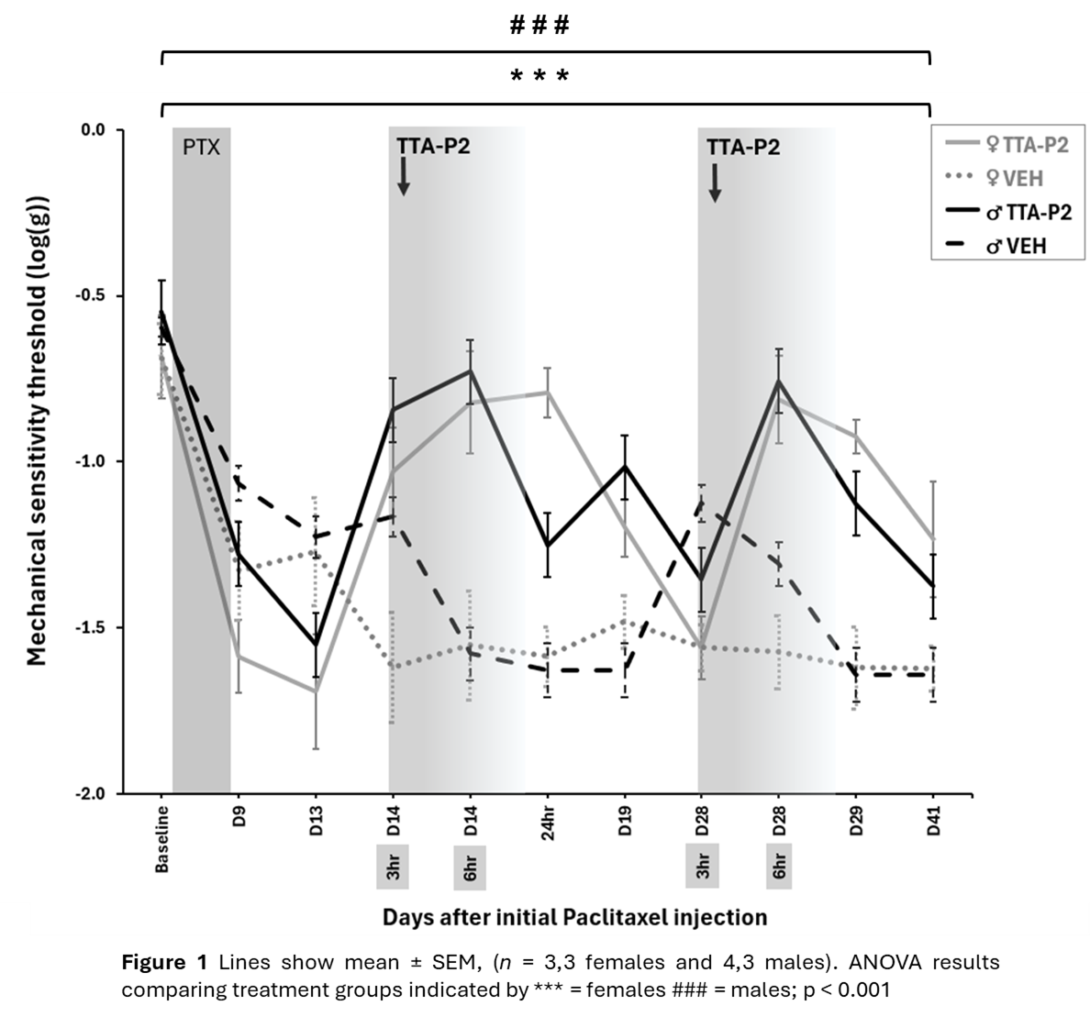In vivo Ca_{V}3 T-type calcium current block improves pain-like behaviours in a mouse model of chronic chemotherapy-induced peripheral neuropathy.
Sofia Fontana-Giusti, Maria Maiarú, Gary J Stephens. Department of Pharmacology, School of Pharmacy, University of Reading, Reading, Berkshire, United Kingdom

Introduction. Approximately 30% of cancer survivors suffer from chronic pain (Brown et al, 2014). Chemotherapy-induced peripheral neuropathy (CIPN) can develop from chemotherapeutics such as paclitaxel (PTX), causing prolonged tactile and thermal allodynia. Low-voltage-activated Ca_{V}3 channels are upregulated in preclinical studies of PTX-induced CIPN (Tomita et al, 2019).
Aims. This study aims to elucidate the role of Ca_{V}3 on CIPN-like behaviours in young and aged mice of both sexes, by in vivo block with selective Ca_{V}3 family inhibitor TTA-P2.
Methods. Aged (15-month-old) and young adult (10-weeks-old) male and female C57BL6 mice received a regimen of 4 ip PTX injections (4 mg/kg) over 8 days (Maiarú et al, 2018). Mice were then injected with ip TTA-P2 or vehicle during pain development and again at the peak of pain-like behaviours. Injections were carried out under 2% isoflurane using an induction chamber.
Results. In aged mice, TTA-P2 improved mechanical hypersensitivity (3-way ANOVA: factor ‘treatment’, p=0.00035, ‘sex’ p=0.099), with a longer-lasting antinociceptive effect when given during development of PTX-induced pain (Figure 1). TTA-P2 was more effective at improving cold hypersensitivity in aged females than aged males (3-way ANOVA: factor ‘treatment’ p= 0.033, ‘sex’ p= 0.047).
Discussion. Our data suggest that Ca_{V}3 channels are involved in CIPN development in a time- and sex-dependent manner. No effective analgesic strategies currently exist for CIPN and the inclusion of sex and age as variables in preclinical research are vital to advancing understanding of this debilitating neuropathy.

Brown, M.R.D., et al (2014) Br J Pain 8(4): p.139-153, Maiarù, M., et al. (2018) Pain 159(7): p. 1224-1234, Tomita, S., et al. (2019) Toxicology 413: p. 33-39.

