Pharmacokinetics and safety of a CYP3A4-metabolised compound: healthy Chinese, Japanese, European participants
Romina Nand¹, Debra Tompson², Hannah Woodcock³, Kasia Okrojek-Swiderek⁴, Katya Mauff⁵, Zahida Elliott⁶, Frances Stringer¹, Masanori Yamada⁷, Xiao Zhang⁸. CPPST, GSK¹, Abbotsford, NSW, Australia; CPQM, GSK², London, UK; APU Respiratory, GSK³, London, UK; SERM, GSK⁴, Warsaw, Poland; Statistics, GSK⁵, London, UK; GCO, GSK⁶, Stevenage, UK; CPMS, GSK⁷, Tokyo, Japan; CPMS, GSK⁸, Shanghai, China.

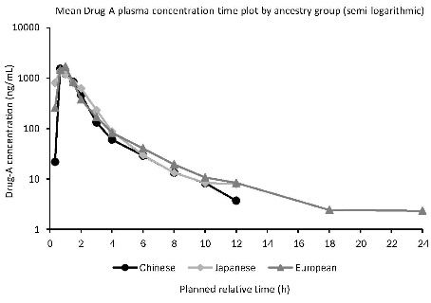
Introduction. Simultaneous global drug development strategies integrating Japan and China into early global multi-centre clinical trials (MRCTs) improve efficiency, reduce drug lag and accelerate patient access to new medicines. To facilitate Japan and China joining global MRCTs, a Phase 1 study in the USA investigated PK and safety of Drug-A in healthy Chinese, Japanese and European participants (GSK-sponsored study 222308). This study enabled inter-ethnic comparisons based on data from a single study for Drug-A, which is primarily metabolised via CYP3A4.
Aims. To evaluate the ethnic sensitivity of Drug-A PK and safety in healthy Chinese and Japanese participants versus European participants.
Methods. This randomised, placebo-controlled, double-blind, parallel-group Phase 1 study enrolled 36 participants (n=12 per ancestry group). Participants received a single oral dose of 160 mg Drug-A or placebo (3:1) under fasted conditions. PK parameters were assessed using non-compartmental analyses, and safety evaluations included adverse events (AEs), clinical laboratory tests, vital signs and electrocardiograms (ECGs).
Results. Drug-A was rapidly absorbed, with median T_{max} of 0.67–0.75 h across ancestry groups. Plasma concentrations declined rapidly after C_{max}, with geometric mean elimination t1/2 from 1.93–2.58 h (Figure). Geometric mean C_{max} and AUC were similar across ancestry groups. Across all ancestry groups, all AEs were mild and considered unrelated to study treatment, with no serious AEs or deaths reported. No clinically relevant changes in laboratory values, vital signs, or ECGs were observed.
Discussion. These findings demonstrate low ethnic sensitivity for Drug-A PK, a compound demonstrating high CYP3A4-dependent metabolism. Conducting such studies early in development would help bring new medicines to Asian markets more efficiently and expeditiously.
Funding: This study (222308) was funded by GSK.

Disclosures:

Author | Employee: Have you been employed by one of the (pharmaceutical) companies? If yes, please list companies. | Grant/research support: Have you received financial grants from pharmaceutical companies (Yes/No)? If yes, please list companies. | Consultant: Have you worked as a paid consultant for (pharmaceutical) companies (yes/No)? If yes, please list companies. | Sponsored lecturer (national or International: Have you been a sponsored lecturer by one of the (pharmaceutical) companies (Yes/No)? If yes, please list companies. | Stockholder: Do you hold any stocks/shares in (pharmaceutical) companies (Yes/No)? If yes, please list companies. | Other conflicts of interest: Do you have any other COIs (Yes/No)? If yes, please specify.
Romina Nand | GSK | No | No | No | I hold GSK shares | None
Debra Tompson | GSK | No | No | No | I hold GSK shares | None
Hannah Woodcock | GSK | GSK | No | No | I hold GSK shares | None
Kasia Okrojek-Swiderek | GSK | No | No | No | I hold GSK shares | None
Katya Mauff | GSK | No | No | No | I hold GSK shares | None
Zahida Elliott | GSK | No | No | No | I hold shares | None
Frances Stringer | GSK | No | No | No | I hold GSK shares | None
Masanori Yamada | GSK | No | No | No | I hold GSK shares | None
Xiao Zhang | GSK | No | No | No | I hold GSK shares | None

