Using Bound! Game to Enhance Pharmacy Students’ Understanding of Drug–Protein Interactions
Ika Nurzijah^{*1}, Monika Wisda Herisman¹, Anjar Mahardian Kusuma¹, Elza Sundhani¹, Susanti¹
Department of Pharmacology and Clinical Pharmacy, Faculty of Pharmacy, Universitas Muhammadiyah Purwokerto
*Corresponding author email: ikanurzijah@ump.ac.id (please abbreviate state)
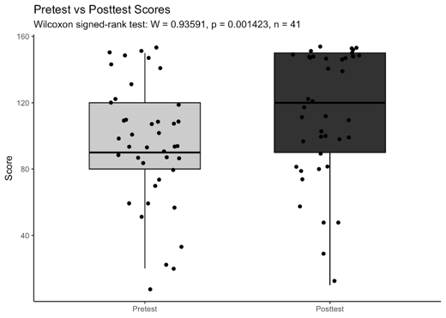
Introduction. Pharmacology is a core subject in pharmacy curricula; however, students often find it challenging to understand the abstract concept of drug–protein interactions. Conventional lecture methods may not fully support comprehension of pharmacodynamics, highlighting the need for interactive learning strategies.
Aims. This study aimed to assess the effectiveness of the Bound! Protein–Drug Matching Game in improving student learning outcomes and to explore perceptions of its use in pharmacology education.
Methods. A quasi-experimental one-group pretest–posttest design was conducted among first-year undergraduate pharmacy students at Universitas Muhammadiyah Purwokerto. A total of 44 students consented to participate. Students engaged in three rounds of the Bound! game in small groups during a 90-minute classroom session. Pretest and posttest multiple-choice assessments measured cognitive performance. An open-ended survey captured student perceptions. Statistical analysis used the Wilcoxon signed-rank test.
Results. Student scores significantly improved following the intervention (W = 0.93591, p = 0.0014, n = 41). The median posttest score was higher and less variable compared to pretest scores, suggesting better conceptual understanding. Qualitative feedback indicated that students found the game enjoyable, interactive, and useful for visualising molecular interactions. Students appreciated the progressive difficulty of the rounds and highlighted the benefits of teamwork.
Discussion. The Bound! Protein–Drug Matching Game was effective in enhancing student comprehension of drug–protein interactions while promoting engagement and collaboration. Integration of such game-based learning tools into pharmacology courses may complement traditional lectures, reduce learning gaps, and foster active participation.
Keywords: active learning, drug–protein interaction, educational game, pharmacology, pharmacy students

