**A strategy to achieve perfect alignment of graphene domains on Cu(111) surface**

*Qinghong YuanA,B, Saiyu BuA,B, Debra BernhardtA,C*

A Centre for Theoretical and Computational Molecular Science, Australian Institute for Bioengineering and Nanotechnology, The University of Queensland, Brisbane, QLD, 4072, Australia;

B State Key Laboratory of Precision Spectroscopy, School of Physics and Electronic Science, East China Normal University, 3663 N. Zhongshan Road, Shanghai 200062, People’s Republic of China

C School of Chemistry and Molecular Biosciences, The University of Queensland, Brisbane, QLD, 4072, Australia

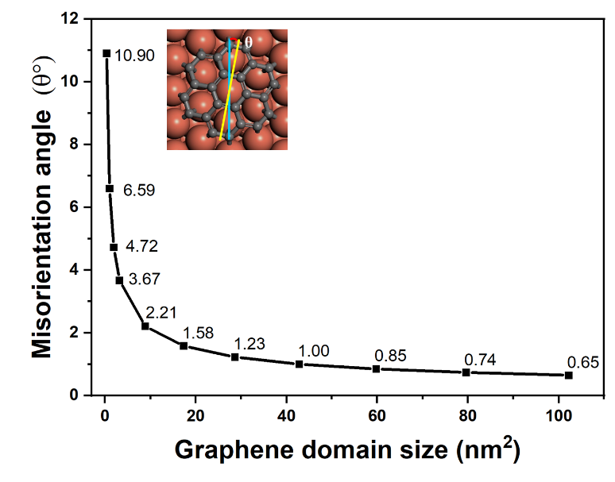 Large single-crystalline graphene wafers are highly desired for realizing many of graphene’s potential applications with the optimal performance.[1] However, the synthesis of wafer-scale single-crystalline graphene has been a great challenge in chemical vapor deposition (CVD) growth due to the nucleation of numerous graphene domains on the supported substrate. One possible way to achieve the growth of single-crystalline graphene with a large area is to align graphene domains on the catalytic substrate, which has been achieved on Ge(110) surface through edge-epitaxial growth.[2,3] Cu(111) surface was proposed to be an ideal substrate to grow single-crystalline graphene through epitaxial growth because it has the same symmetry as that of graphene. However, graphene monolayers grown on most of the single-crystalline Cu(111) surface were found to be polycrystalline with numerous grain boundaries, [4,5] which has been a long puzzling in the graphene growth field. In this work, based on physical model and first principles theoretical calculations, we found that graphene domains with small size always have misorientation angles in relative to the underlying Cu(111) substrate because the vertexes of the graphene domain have preferred binding orientation with the Cu(111) substrate. For example, the misorientation angle between C24 and the Cu(111) surface is 10.9°, where C atoms on the vertices of C24 bind with Cu atoms along [-110] orientation, as shown by the inserts of the right figure. With the increase of graphene domain size, the misorientation angle becomes smaller, as shown in the figure. Our theoretical calculations demonstrate that the perfect alignment of graphene domains on Cu(111) substrate can be only achieved with large graphene domains or low nucleation density of graphene.

**References**

1. Geim, A. K., (2009) Graphene: Status and Prospects. *Science*, *324*, 1530-1534.
2. Lee, J.-H.; Lee, E. K.; Joo, W.-J.; Jang, Y.; Kim, B.-S.; Lim, J. Y.; Choi, S.-H.; Ahn, S. J.; Ahn, J. R.; Park, M.-H.; Yang, C.-W.; Choi, B. L.; Hwang, S.-W.; Whang, D. (2014) Wafer-Scale Growth of Single-Crystal Monolayer Graphene on Reusable Hydrogen-Terminated Germanium. *Science*, 344, 286–289.
3. Dai J., Wang, D., Zhang, M., Niu, T., Li, A., Ye, M., Qiao, S., Ding, G., Xie, X., Wang, Y., Chu, P. K., Yuan, Q., Di, Z., Wang, X., Ding, F., Yakobson, B. I., (2016) How graphene islands are unidirectionally aligned on Ge(110) surface. *Nano Letters*, 16, 3160.
4. Ago, H.; Ohta, Y.; Hibino, H.; Yoshimura, D.; Takizawa, R.; Uchida, Y.; Tsuji, M.; Okajima, T.; Mitani, H.; Mizuno, S.(2015) Growth Dynamics of Single-Layer Graphene on Epitaxial Cu Surfaces. Chem. Mater., 27, 5377–5385.
5. Gao, L., Guest, J. R., Guisinger N. P., (2010) Epitaxial Graphene on Cu(111). Nano Lett., 10, 3512–3516.