Artificial Intelligence-driven Design of Humanized Antibodies for immunotherapy
Qi Zhao¹, Defang Ouyang^{1,2}.
¹Faculty of Health Sciences, University of Macau, Taipa, Macau SAR, China;
²Institute of Chinese Medical Sciences, University of Macau, Macau SAR, China.

Background and aims. Anti-B7-H3 monoclonal antibody (mAb) omburtamab has been primarily investigated for central nervous system (CNS) tumors and neuroblastoma. A key antitumor mechanism of omburtamab is antibody-dependent cellular cytotoxicity (ADCC). Recent advances in artificial intelligence (AI) have facilitated more efficient antibody design and optimization, enabling the enhancement of antibody efficacy while preserving low immunogenicity.

Methods. We employed in silico-guided affinity maturation to engineer therapeutic monoclonal antibodies targeting HER2 and B7-H3. AI-driven structural modeling, computational mutagenesis, and yeast display technologies were integrated to identify mutations that enhance antigen binding (Figure 1). Selected antibody variants were further evaluated for ADCC activity and antitumor efficacy both in vitro and in vivo.
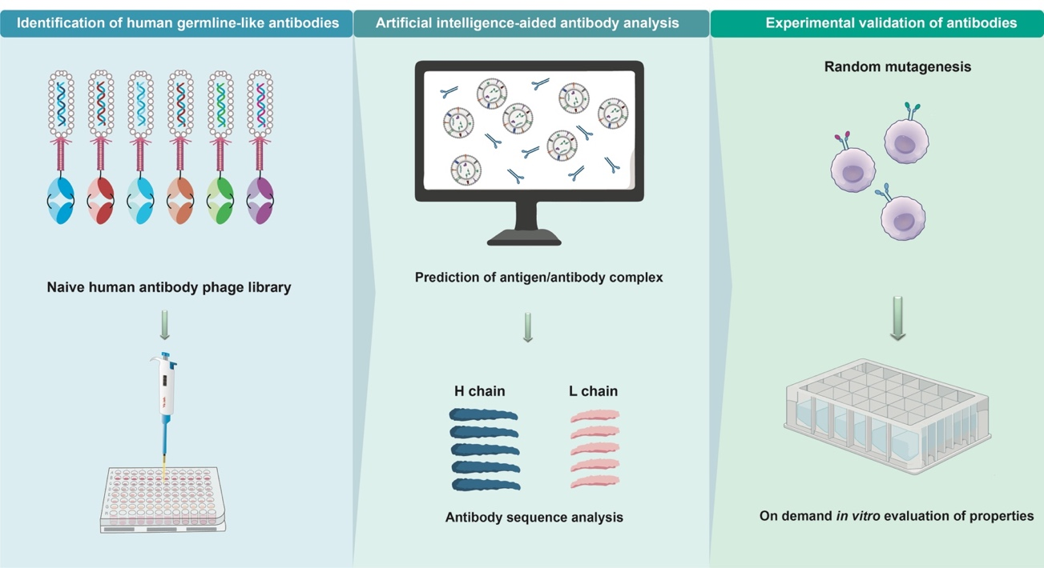
Figure 1. Schematic illustration of AI-aided antibody design and optimization.

Results
High-affinity antibody variants were successfully developed using yeast display and AI-assisted modeling. The affinity maturation of anti-B7-H3 mAb omburtamab yielded a humanized variant with up to 160-fold increased affinity and potent ADCC activity. Similarly, an affinity-matured anti-HER2 antibody (Ab5m) exhibited a 7.5-fold improvement in binding affinity (K_{D} = 0.2 nM vs. 1.5 nM) and significantly enhanced ADCC, resulting in superior tumor suppression in vivo, both as a monotherapy and in combination with high-affinity omburtamab.
Conclusions. These results highlight the power of AI-guided affinity maturation in optimizing antibody therapeutics for cancer immunotherapy. This strategy enables the generation of safer and more effective mAbs with enhanced antitumor efficacy and reduced immunogenicity, offering promising avenues for clinical translation.
Acknowledgements. This work was supported by the Science and Technology Development Fund of Macau (FDCT/0009/2023/RIC).

References:
(1) Zhou, G. et al. (2025) Journal of Immunology, vkaf063.
(2) Ahmed, M. et al (2015) Journal of Biological Chemistry, 290(50), 30018.
(3) Zhao, Q. etal (2015) Leukemia, 29(11), 2238.

