**Osteocyte-Targeting System Using Thermo-Responsive Self-Assembled Nanocarrier for CKD-MBD Treatment**

**Shugo Yamashita1**, Hidemasa Katsumi2, Akiko Kiriyama1

Department of Pharmacokinetics, Doshisha Women’s College of Liberal Arts1, Kyotanabe, Kyoto, Japan;

Department of Pharmacology Toxicology and Therapeutics, SHOWA Medical University2, Shinagawa, Tokyo, Japan.

**Background and aims.** Kidney fibrosis initiated by chronic kidney disease-mineral and bone disorder (CKD-MBD) is induced by the secretion of fibroblast growth factor 23 (FGF23) from the bone 1). However, inhibition methods for curing kidney fibrosis associated with CKD-MBD have not been established. In this study, we developed a therapeutic approach for kidney fibrosis using a diblock co-polypeptide (polyD-poly(D/F)n abbreviated as DDF).

**Methods.** Fluorescein isothiocyanate-labaled DDF encapsulating GW0742, a peroxisome proliferator-activated receptor γ agonist, (FITC-DDF-GW) was intravenously injected into mice and the lower limb bones were removed under euthanized. Undecalcified frontal tissue sections were prepared from the distal femur and proximal tibia. Cathepsin K, collagen I, and phalloidin were stained using immunofluorescent. The sections were observed under a confocal microscope. DDF-GW was injected into the CKD-MBD model mice. The lower limbs of the mice were heated at 44–45°C for 10 min under anesthesia after DDF-GW injection, and blood was collected from the tail vein to obtain serum for FGF23 and phosphorus level evaluation.

**Results.** Circular dichroism and linear dichroism showed that DDF has an alpha-helical structure and an orientation perpendicular to the helical axis. Atomic force microscopy revealed that DDF self-assembled into spherical structures approximately 70 nm in diameter. DDF exhibited thermo-responsive up to 45°C and released GW0742 in a temperature-dependent manner. DDF-GW was distributed in the lower limb bone at approximately 9.9% of the GW0742 dose/g of tissue up to 1h after injection. Micro-distribution analysis of the lower limb bones in mice revealed that FITC-DDF-GW was distributed in the osteocyte dendritic network. In the CKD-MBD mouse models, the combination of DDF-GW administration and lower limb heating significantly decreased blood FGF23 levels at 6 h post-treatment to 1/5th of that before treatment.

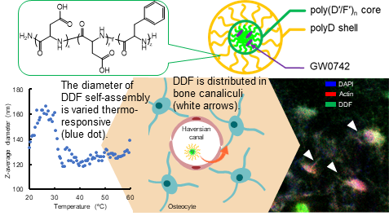

**Figure 1.** Diagram of DDF-GW (top panel). DDF is thermo-responsive (left panel). Additionally, DDF was distributed in the osteocyte dendritic network (right panel).

**Conclusion/Discussion.** We designed a bone-targeting self-assembly (DDF) composed entirely of amino acids, using a pharmacokinetic approach. The DDF was thermo-responsive. Fluorescence immunostaining of DDF in the bone showed that DDF accumulated in osteocytes through the bone canaliculi network. DDF-GW exhibited short-term regulation of FGF23 secretion. These results suggest that DDF may be a next-generation drug delivery material for efficient bone targeting in bone-related diseases.

**References:**

(1) Kuro-o, M. (2013) Nat. Rev. Nephrol. 9(11):650–660