Kidney-targeted antioxidant salvianolic acid B nanoparticles for acute kidney injury therapy
Xiao-Ming Zhu, Jian-Li Chen. State Key Laboratory of Quality Research in Chinese Medicine, Macau University of Science and Technology, Taipa, Macau SAR, China.

Introduction. Acute kidney injury (AKI) is highly correlated with oxidative stress, and the application of antioxidants is one of the promising treatments.
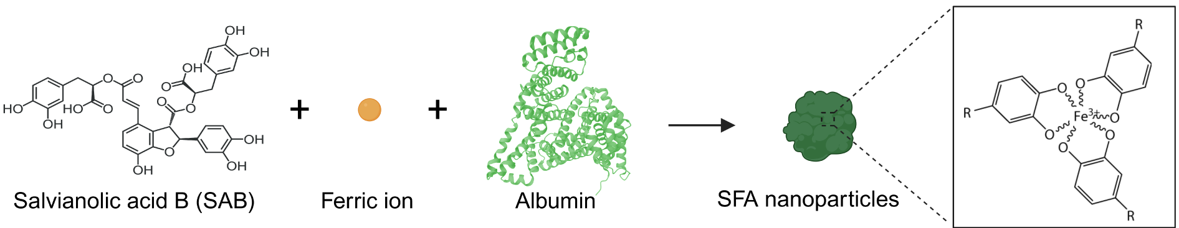
Aims. Salvianolic acid B (SAB) is a natural polyphenol with powerful antioxidant effects. Due to its inherent characteristic of inferior bioavailability, its clinical application is impeded. Aided by the advantages of nanotechnology, the SAB-based nanoparticles were synthesized to improve SAB’s therapeutic efficacy for treating AKI.
Methods. In this study, small SAB-incorporated nanoparticles (SFA) were synthesized via the self-assembly of SAB, ferric ions, and bovine serum albumin (BSA). The in vivo distribution of SFA were studied in the AKI model mice induced by glycerol. The effects of SFA and SAB were compared in both in vitro and in vivo studies.
Results. Apart from antioxidant activity, the SFA nanoparticles were found to efficiently restore lysosome dysfunction induced by reactive oxygen species (ROS) in human kidney proximal tubular epithelial HK-2 cells. The small size and BSA incorporation make the SFA nanoparticles to be promising AKI-targeting nanoparticles. They are rapidly accumulated and long-term retained in injured kidneys of glycerol-induced AKI mice, especially in the proximal tubules which are the key lesion location during AKI. In vivo studies indicate that SFA nanoparticles show a superior protective effect compared with the free drug by suppressing oxidative stress and maintaining lysosome homeostasis indicated by enhanced heme oxygenase-1 (HO-1) expression and restored cathepsin B (CTSB) activity, respectively.
Discussion. In summary, this study develops a delivery system for the antioxidant SAB enhancing local delivery and offering additional lysosome restoring mechanism for AKI therapy.
Acknowledgements. This work was funded by The Science and Technology Development Fund, Macau SAR (File no. 0035/2022/A1, 0168/2019/A3).

