**Repurposing Cardiac Glycosides to Potentiate CD47 Blockade through Calreticulin-mediated Phagocytic Effect in Lung Cancer**

Zi-Han Ye**1**, Wei-Bang Yu1, Mu-Yang Huang1, Yan-Yan Chen1, Le-Le Zhang4, Chung-Hang Leung1, Xiao-Lei Zhang5, Zheng-Hai Tang6, Ting Li1, **Jin-Jian Lu**1,2,3

1 State Key Laboratory of Quality Research in Chinese Medicine, Institute of Chinese Medical Sciences, University of Macau, Macao, China;

2 Department of Pharmaceutical Sciences, Faculty of Health Sciences, University of Macau, Macao 999078, China;

3 MoE Frontiers Science Center for Precision Oncology, University of Macau, Macao 999078, China；

4 School of Basic Medical Sciences, Chengdu University, Chengdu 610106, China;

5 National-Local Joint Engineering Laboratory of Druggability and New Drug Evaluation, Guangdong Key Laboratory of Chiral Molecule and Drug Discovery, School of Pharmaceutical Sciences, Sun Yat-sen University, Guangzhou 510006, China;

6 Department of Biomedical Sciences, Faculty of Health Sciences, University of Macau, Macao 999078, China.

**Background and aims.** CD47 serves as “don’t eat me” signal in cancer, novel CD47-targeted combination strategies warrant further investigation. This study aims to explore the anti-cancer effect and mechanisms of new combination strategy between CD47 antibody and cardiac glycosides (CGs).

**Methods.** High-content screening assay; *In-vitro* and *in-vivo* phagocytosis assay; anti-cancer evaluation in xenograft model; FACS assay, *etc*.

**Results.** Two CGs, ouabain and digoxin, were identified to enhance the phagocytic activity of CD47 antibody in compound screening system (Figure 1a). In xenograft models, ouabain significantly inhibited tumor growth (Figure 1b, c) and increased the phagocytosis of tumor-associated macrophages (Figure 1d). Mechanistically, CGs augmented the cell surface expression of calreticulin (CRT) (Figure 1e, f). The enhanced phagocytosis induced by the combination treatment was reversed by an anti-CRT blocking antibody (Figure 1g). Further investigation revealed that CGs disrupted endoplasmic reticulum (ER)-Ca²⁺ homeostasis, leading to PERK activation. The PERK inhibitor GSK157, ER-Golgi protein trafficking inhibitor BFA, and siRNA targeting Exo70 effectively reversed CGs-induced CRT upregulation and phagocytosis enhancement (Figure 1h-j).

**Conclusion/Discussion.** CGs enhanced anti-cancer effect of CD47 antibody by inducing CRT translocation via ER-Golgi-exocytosis pathway. This finding provides new insights for both drug repurposing of CGs and combination strategies involving CD47 in cancer.

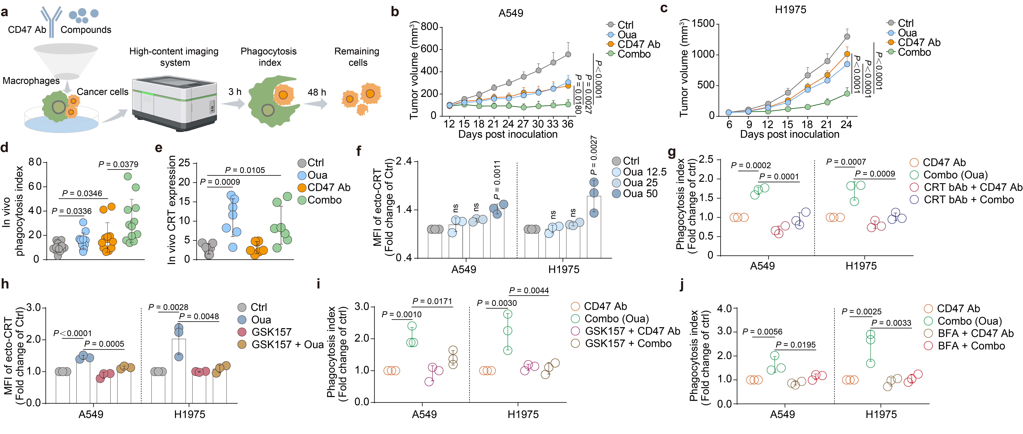

Figure 1. CGs enhanced the anti-cancer effect of CD47 blockade through CRT-mediated phagocytosis in lung cancer.

**Acknowledgement:** This study was supported by University of Macau (File No. MYRG-GRG2024-00113-ICMS-UMDF) and the Science and Technology Development Fund, Macau SAR (File No. 0015-2022-A1 and 005/2023/SKL).