Anti-Neuroinflammatory Potential of Psychoactive Alkaloids from Chinese Medicinal Plants by Targeting TREM2
Lin Li ¹, Cheryl Hei Ting Kwong ², Grace Chen Zhao ², Ben-Qin Tang ^{2∗}, Simon Ming-Yuen Lee ^{2∗∗}
¹ Institute of Chinese Medical Sciences, University of Macau, Macau, China; ² Department of Food Science and Nutrition, The Hong Kong Polytechnic University, Hong Kong, China

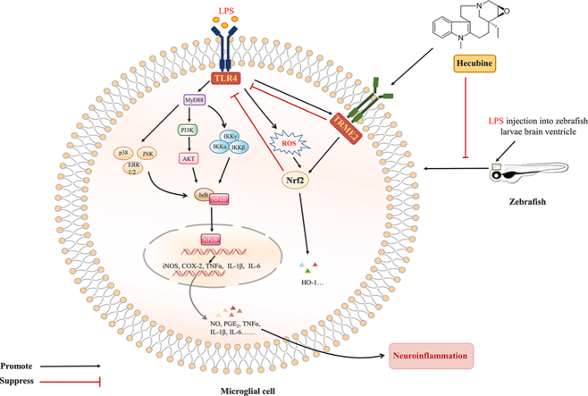
Introduction. Neuroinflammation play a crucial role in the pathogenesis of neurodegenerative diseases. The triggering receptor expressed on myeloid cells 2 (TREM2), highly expressed by microglia in the central nervous system (CNS), can modulate neuroinflammatory responses.
Aims. This study aimed to elucidate the potential therapeutic effect of different Iboga-type alkaloids (ITAs), such as Hecubine and Dehydroervatamine, as TREM2 activators in LPS stimulated experimental neuroinflammation.
Methods. Molecular docking and cellular thermal shift assay (CTSA) were employed to assess the binding affinity and interaction of the ITAs with TREM2. Anti-inflammatory effects were evaluated via ELISA, quantitative PCR, immunofluorescence, and Western blotting.
Results. Selected ITAs were shown to directly bind to and activate TREM2. TREM2 knockdown significantly attenuated the inhibitory effects of the ITAs on LPS-induced production of proinflammatory mediators (NO, TNF-α, IL-6, and IL-1β) in microglial cells. In both in vitro and in vivo models, the ITAs upregulated Nrf2 expression and suppressed TLR4 signaling. Silencing TREM2 resembling the phenotypic effects of LPS exposure and counteracting the effects of ITAs.
Discussion. This is the first study to identify ITA small molecules directly targeting TREM2 to mediate anti-neuroinflammation and anti-oxidative effects, which serves as potential therapeutic agents for the treatment of neural inflammation-associated CNS diseases.
Li L et al (2024) Redox Biol. 70:103057.
Li L et al (2025) Neurotherapeutics. 22(2):e00479

