LHRH Receptor as a Therapeutic Target in TNBC: From Quantitative Profiling to Preclinical Evaluation of a Peptide-Drug Conjugate

Rafia Ali ^{1,2}, Pegah Varamini ¹, Dinny Graham ²
School of Pharmacy ¹, Faculty of Medicine and Health, University of Sydney, Sydney, NSW 2006, Australia.
Westmead Institute of Medical Research², Westmead, NSW, Australia.

Background and aims. Breast cancer remains a leading cause of cancer-related mortality among women globally. Among its subtypes, triple-negative breast cancer (TNBC) is the most aggressive, accounting for disproportionately high rates of recurrence and mortality due to the lack of targeted therapies. One promising yet underexplored molecular feature of TNBC is the expression of the luteinizing hormone-releasing hormone (LHRH) receptor, which may serve as a viable target for precision drug delivery. However, current data on LHRH receptor expression in TNBC remain fragmented, with limited integration of quantitative and spatial analyses.
Methods/Results. To address this gap, we conducted a comprehensive evaluation of LHRH receptor expression in TNBC cell lines using flow cytometry for quantification and immunohistochemistry (IHC) for spatial localisation. Building on this foundation, we developed a novel peptide-drug conjugate (PDC) with high affinity for the LHRH receptor, conjugated to a potent anticancer payload, specifically designed to exploit this receptor as a therapeutic entry point. The efficacy of the PDC was evaluated in vivo using mouse xenograft models established with LHRH receptor-expressing TNBC cells.
To enhance antigen detection and achieve high-resolution receptor mapping, we optimised staining protocols using horseradish peroxidase (HRP)-conjugated streptavidin and 3,3′-diaminobenzidine (DAB), enabling co-localised analysis with Ki-67 as a marker of cellular proliferation (Figure 1). Recognising the limitations of conventional in vitro systems, we further established patient-derived organoid cultures to better mimic the tumour microenvironment and allow dynamic assessment of receptor expression under near-physiological conditions (figure 2).
1.

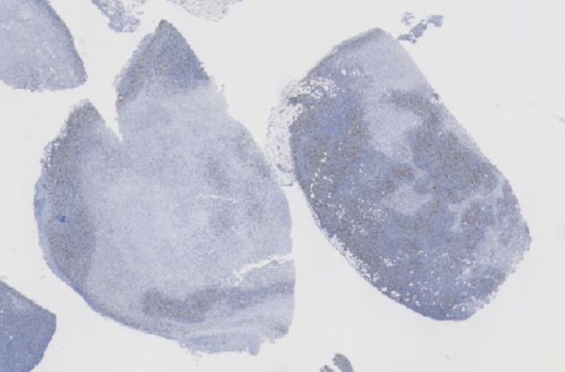 | 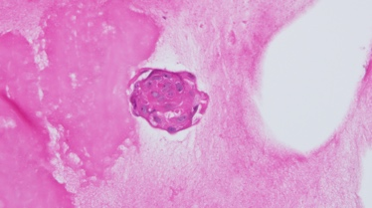  2. a.  b.
Figure 1. Xenograft blocks stained with HRP-streptavidin and DAB for ki-67 analysis Figure 2. Breast tissue organoids a. Untreated with PDC b. Treated with PDC

Conclusion/Discussion. This integrated strategy combines molecular profiling, in vivo validation, and advanced ex vivo modelling to deliver a multidimensional characterisation of LHRH receptor expression in TNBC. Our findings support its potential as a clinically actionable target and demonstrate the therapeutic promise of the PDCs in addressing the critical treatment gap for patients with TNBC.
References:
- Ali, R.; Shao, H.; Varamini, P. Potential Nanotechnology-Based Therapeutics to Prevent Cancer Progression through TME Cell-Driven Populations. Pharmaceutics 2023, 15, 112.
- Seitz S, Buchholz S, Schally AV, Weber F, Klinkhammer-Schalke M, Inwald EC, Perez R, Rick FG, Szalontay L, Hohla F, Segerer S, Kwok CW, Ortmann O, Engel JB. Triple negative breast cancers express receptors for LHRH and are potential therapeutic targets for cytotoxic LHRH-analogs, AEZS 108 and AEZS 125. BMC Cancer. 2014 Nov 19;14:847. doi: 10.1186/1471-2407-14-847. PMID: 25410881; PMCID: PMC4289186.

