**Targeting glycans on diseased brain cells with fluorescent nanodiamonds**

*Lindsay Parker*A*, Philipp ReineckB, Mina Ghanimi FardA, Nicole CordinaA, Michael BarattaC, Zahra KhabirA,Sameera IqbalA, Nicki PackerA*

ADepartment of Molecular Sciences and ARC Centre of Excellence for Nanoscale Biophotonics, Macquarie University, Australia BDepartment of Physics and ARC Centre of Excellence for Nanoscale Biophotonics, RMIT University, Australia CUniversity of Colorado Boulder, USA

Introduction. Nanodiamonds are cheap as well as easy to synthesize and functionalise with high biocompatibility therefore have versatile applications in biology and nanomedicine (Neburkova, Vavra et al. 2017, Chipaux, van der Laan et al. 2018). Cell-surface glycan receptors mediate the initial contact between cells and exogenous proteins and these receptors are the most abundant and functionally important type of post-translational modification associated with brain development, neurodegenerative disorders, psychopathologies and brain cancers (Iqbal, Ghanimi Fard et al. 2018). The interaction of lectins with cell surface glycan receptors readily triggers endocytosis and subsequent trafficking to intracellular organelles, providing a good opportunity for development in targeted nanoparticle based drug delivery.

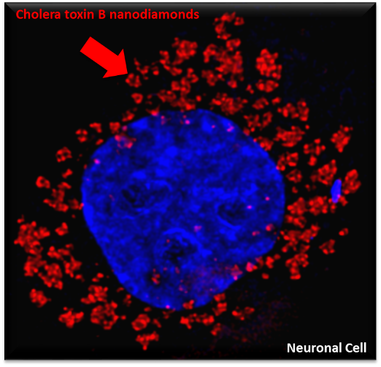Aims. We hypothesised that lectin proteins, which target glycans on the cellular membrane of brain cells with high affinity, could be conjugated to the surface of nanodiamonds. We aimed to investigate the uptake of lectin/nanodiamond complexes in three types of cultured brain cells- neurons, microglia and astrocytes *in vitro* as well as *in vivo* brain cells.

Methods. Using EDC/NHS chemistry and a PEG-22 spacer arm, we coated fluorescent nanodiamonds with lectin proteins including cholera toxin B, wheat germ agglutinin and *Aleuria aurantia* lectin and tested their ability to enter specific brain cell types.

Results. Lectin coated nanodiamonds were successfully endocytosed by neurons (Fig. 1), microglia and astrocytes *in vitro* and *in vivo*. They remained in these cells for at least 48 hours with minimal stress to the host cells or animals. *Aleuria aurantia* lectin coated diamonds showed a binding preference for human glioblastoma phenotype astrocyte cells in contrast to the other lectins investigated. Cholera toxin B and wheat germ agglutinin coated nanodiamonds were well endoctyosed *in vivo* in rat brain cells.

**Fig 1.** Cholera toxin B nanodiamonds endocytosed by a neuronal cell, surrounding a nucleus.

Conclusion. Lectin/nanodiamond complexes open a new opportunity for developing an efficient nanoparticle based drug carrier that is targeted and easily endocytosed by brain cells. With known increases in specific glycan receptors during brain diseases there is great promise for such a system to be utilized for their treatment.

**References**

1. Chipaux, M., K. J. van der Laan, S. R. Hemelaar, M. Hasani, T. Zheng and R. Schirhagl (2018). "Nanodiamonds and Their Applications in Cells." Small **14**(24): 1704263.
2. Iqbal, S., M. Ghanimi Fard, A. Everest-Dass, N. H. Packer and L. M. Parker (2018). "Understanding cellular glycan surfaces in the central nervous system." Biochemical Society Transactions: BST20180330.
3. Neburkova, J., J. Vavra and P. Cigler (2017). "Coating nanodiamonds with biocompatible shells for applications in biology and medicine." Current Opinion in Solid State and Materials Science **21**(1): 43-53.

lindsay.parker@mq.edu.au