Development of Online Assessment Database to Improve Quality, Consistency and Efficiency
Slade Matthews, Megan Anakin, Andrew Bartlett, Tina Hinton, Kellie Charles, Rebecca Roubin
Sydney Pharmacy School, The University of Sydney, Sydney, NSW, Australia
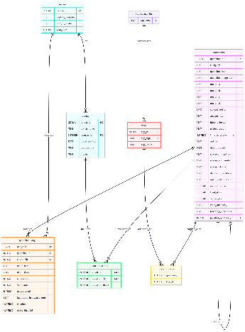
Introduction. Manual management of assessment data is time-consuming and limits the ability to track item performance or maintain accessible historical records. An online assessment database can address these limitations by enabling item anaylsis¹, streamlining workflows, and supporting standard-setting processes. However, the database must also be designed for the specific needs of educators. Currently, there is no affordable, commercially available database tailored for pharmacy and pharmacology education.
Aims. To design and develop an online assessment database to automate creation, storage, administration, and retrieval of multiple-choice questions in pharmacy and pharmacology education.
Methods. The database was designed and developed following stakeholder consultations and SWOT analysis to identify essential features. Key functionalities included question management and tagging, reporting functions, and a wish list including role-based access and logging. The technical architecture was based on cptlab.au design stack.
Results. The database design is represented by an Entity-Relationship Diagram (ERD, Fig. 1) showing flags and metadata necessary for item evaluation and cataloguing. The tech stack includes PostgreSQL database, Flask backend, and Bootstrap frontend, with deployment via Nginx (web traffic) and Gunicorn (Python application server).
Discussion. The database will provide a secure, centralised repository for MCQs, enabling metadata-driven organisation to support educators to compile balanced assessments efficiently. The next step is to pilot test with a limited number of educators to evaluate usability and searchability. Further training about MCQ construction and evaluation is planned.

¹Szyjewski, G. (2025) In: Hernes, M., Wątróbski, J., Rot, A. (eds) ECAI 2024. Lecture Notes in Networks and Systems, vol 1217. Springer, Cham.

