**Localized and Precise Cancer Therapy Enabled by 3D-Printed Drug Delivery Systems**

**Yunmei Song**, Souha Youssef, Paris Fouladian, Sanjay Garg.

Clinical and Health Sciences, University of South Australia, Adelaide, South Australia, Australia;

**Background and aims.** Cancer remains a clinical challenge with overall poor prognosis and limited survival. Despite the fact that surgical resection remains the treatment of choice for early- to intermediate-stage cancers, recurrence can be expected in the presence of residual microscopic cancer cells along the margin of resection. Adjuvant chemotherapy in such cases is administered. Systemic chemotherapy is not, however, without its own setbacks of dose-limiting toxicity, inefficient drug distribution, and multidrug resistance. These limitations emphasize the need for site-directed, localized drug delivery systems. Drug-eluting systems are one such system and are proving to be useful tools due to the ability to deliver sustained, site-directed treatment with improved safety and efficacy.

**Methods.** Biodegradable drug-eluting systems loaded with anticancer compounds were prepared with 3D printing technology by our team. Differential scanning calorimetry (DSC), X-ray diffraction (XRD), Fourier-transform infrared spectroscopy (FTIR), thermogravimetric analysis (TGA), and scanning electron microscopy (SEM) were used to explore physicochemical properties. Stability was evaluated to ensure long-term integrity of the delivery system under different storage conditions. Uniformity of drug content was assessed, and systematically the influence of varying infill densities on drug release kinetics was investigated to determine the feasibility of controlling release profiles through structural design.

**Results.**

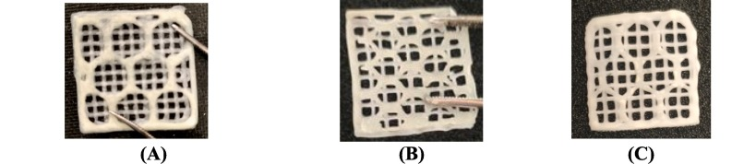 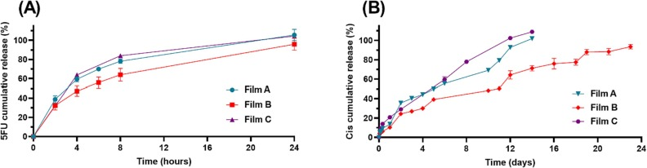

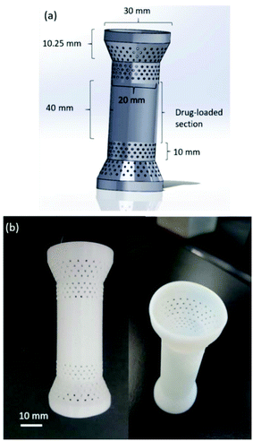 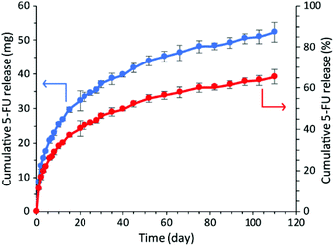

**Figure 1.** 3D printed film and stent; the drug release profiles.

**Conclusion/Discussion.** Recurrence of cancer in the post-operative period continues to be a major issue because of lingering malignant cells. Adjuvant localized chemotherapy is a focused strategy to eradicate these cells without causing undue systemic toxicity. Our work describes an individualizable, biodegradable 3D-printed drug delivery system that can deliver chemotherapeutic drugs with high precision and localization at the site of the removed tumor. The developed platform is promising for patient-specific cancer treatment, synchronizing treatment interventions with the needs of the individual patient, and enhancing post-surgical results.

**References:**

(1) Souha H. Youssef. et al (2024) Int. J. Pharm.,651, 123790.

(2) Paris Fouladian. et al (2020) Biomater. Sci., 6625-6636