Clinical pharmacologist–Artificial Intelligence partnership for safer paediatric prescribing: a multicentre study
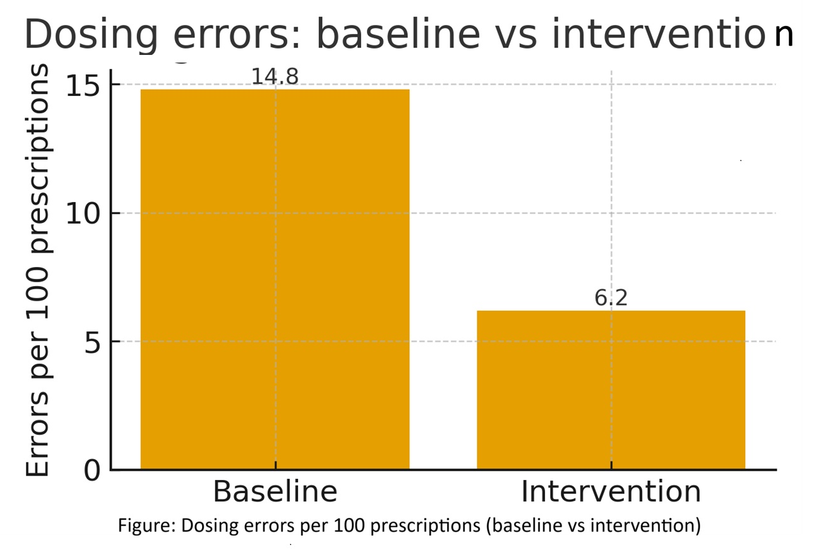
C. M. Kamaal^{1,}, Pramod Yadav², Sukanta Sen³, Sk Rafikul Rahaman⁴
Dept of Pharmacology¹, SMMH Govt Medical College, Saharanpur, UP, India; Dept of Paediatrics², SMMH Govt Medical College, Saharanpur, UP, India; Dept of Pharmacology³, ICARE IMS&R, Haldia, West Bengal, India; Dept of Paediatrics⁴, ICARE IMS&R, Haldia, West Bengal, India.
Introduction: Children are vulnerable to dosing errors due to weight‑based calculations, age limits, and formulation variability. We implemented a real‑time AI prescription audit to check key dosing rules and support rapid correction by clinicians.
Aims: 1) Measure dosing‑error rates in paediatric prescriptions; 2) test whether an AI‑with‑pharmacologist audit detects and reduces these errors; 3) identify common error types and effective fixes.
Methods: Prospective pre–post quality‑improvement study across OPD, emergency, wards at two tertiary hospitals in India. Baseline surveillance for four months was followed by four months of AI‑assisted auditing with clinical pharmacologist oversight. The AI checked weight‑based dose (mg/kg), maximum daily dose, age appropriateness, decimal/units, renal adjustment (bedside Schwartz eGFR), label‑guided hepatic adjustment, infusion rates, duplicate therapy, and key interactions. High‑risk flags were routed to a pharmacologist for same‑day review and recommendations. Primary outcome: dosing errors per 100 prescriptions (independently verified). Secondary: time to correction, acceptance of recommendations, false‑positive rate, and 30‑day drug‑related revisit.
Results: We reviewed 486 prescriptions for 312 children. Dosing errors fell from 14.8 to 6.2 per 100 prescriptions (36/244 vs 15/242; rate ratio 0.42, 95% CI 0.23–0.77). Median time to correction improved from 18 to 10 minutes. Clinicians accepted 76% of recommendations. After rule tuning, false‑positive alerts decreased from 29% to 13%. The most frequent issues were antibiotic overdosing (aminoglycosides/cephalosporins), decimal/units errors in liquids, and missed renal adjustments. Thirty‑day drug‑related revisits did not increase (2.3% vs 2.1%, p=0.81).
Discussion: Pairing AI speed with clinical pharmacologist judgment reduced paediatric dosing errors while keeping alert burden manageable. The approach is low‑cost and scalable across Indian settings. Remaining gaps include fixed‑dose combinations and newly launched products, which still require expert review.
Conclusion: A clinical pharmacologist–AI partnership can make paediatric prescribing safer at scale.
Singh H, Nim DK, Randhawa AS, Ahluwalia S. Integrating clinical pharmacology and artificial intelligence: potential benefits, challenges, and role of clinical pharmacologists. Expert Rev Clin Pharmacol. 2024 Apr;17(4):381-391. doi: 10.1080/17512433.2024.2317963. Epub 2024 Feb 15. PMID: 38340012.
Foote HP, Cohen-Wolkowiez M, Lindsell CJ, Hornik CP. Applying Artificial Intelligence in Pediatric Clinical Trials: Potential Impacts and Obstacles. J Pediatr Pharmacol Ther. 2024 Jun;29(3):336-340. doi: 10.5863/1551-6776-29.3.336. Epub 2024 Jun 10. PMID: 38863862; PMCID: PMC11163899.

