**Smart Polymer-Coated Hybrid Calcium Phosphate Nanoparticles for Oral Vaccine Delivery**

*Li Li*

Australian Institute for Bioengineering and nanotechnology, The University of Queensland, Australia. E-mail: l.li2@uq.edu.au

**Abstract**

Vaccine has been limited in oral administration due to its low immune response compared to parenteral administration. The antigen degradation in acidic gastrointestinal environment (GI), mucus barriers and inefficient cellular uptake by immune cells are the major challenges for oral vaccine delivery. In this research, we have developed the “smart” polymer-coated calcium phosphate nanoparticles (poly-CaP NPs) as a nanocarrier for oral protein antigens delivery, as shown in Figure 1. The poly-CaP NPs as a nanoadjuvant enable to encapsulate protein antigens, protect the antigens against acidic degradation in GI, controllably release the antigens at various pH, and enhance the cellular uptake of antigens to stimulate immune response.

**Figure 1** Schematic diagram of CaP-Chi-Algi@BSA-FITC nanocomposite. TEM images of CaP, CaP@BSA-FITC, CaP-Chi@BSA-FITC and CaP-Chi-Algi@BSA-FITC (i-iv); and the particle size distribution of CaP, CaP@BSA-FITC, CaP-Chi@BSA-FITC and CaP-Chi-Algi@BSA-FITC (v-viii).

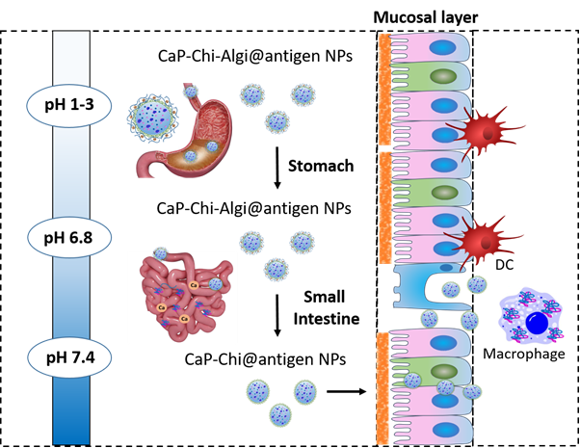As designed, CaP NPs with the particle size around 14 nm have efficiently encapsulated protein antigens with the loading capacity of 90 mg/g. To protect the antigens against acidic degradation in gastrointestinal (GI) environment and target the small intestine, core-shell alginate-chitosan CaP@antigen (CaP-Chi-Algi@BSA) nanocomposites have been constructed by coating and crosslinking chitosan and alginate polymers on CaP NPs. CaP-Chi-Algi nanocomposites enabled to protect 90% of protein release at pH 1.2, following with the sustained release in simulated intestinal (pH 6.8) and colonic fluids (pH 7.4). After passing through the stomach, chitosan-coated CaP NPs have shown the enhanced cellular uptake in Caco-2 cells and macrophages and further increased the surface expression of costimulatory molecules on macrophages. The smart core-shell CaP-Chi-Algi nanocomposites have a great potential for oral vaccine delivery.

**Figure 2** Schematic diagram of mechanism of oral vaccination process and induction of intestinal immune responses.