***Lumbriculus variegatus* as an emerging invertebrate model for pharmacological research and education**Aidan Seeley1. Swansea Worm Integrative Research Laboratory (SWIRL), Swansea University Medical School1, Swansea, Wales, United Kingdom.

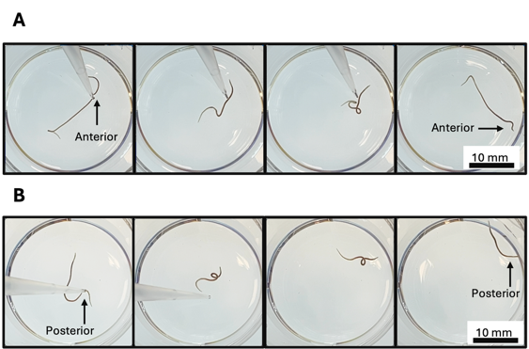

**Introduction.** *Lumbriculus variegatus,* more commonly known as the blackworm, is an aquatic, regenerative, asexually reproducing worm that has recently been developed as a novel model for pharmacological research and education (Seeley et al. 2021; 2024; Carriere et al. 2023; Davies et al. 2025; Williams et al. 2025).

**Aims**. The aim of this workshop is to outline key methodologies used in behavioural measurements of *L. variegatus* and their applications in pharmacological education and research.

**Methods**. Unstimulated movement of *L. variegatus* is quantified using ImageJ software, while tactile stimulation of the anterior (A) and posterior (B) of *L. variegatus* can evoke stereotyped behaviours which can be quantified using a scoring system before, during, and after drug exposure.

**Results.** The session will outline key findings from diverse pharmacologically active compounds including ethanol (Seeley et al. 2024), nicotine (Davies et al. 2025) and cannabidiol (Williams et al. 2025).

**Discussion.** *L. variegatus* represents a cost-effective organism for practical *in vivo* skills using whole organisms without the need for specialised equipment. The session will present the model, and methodologies, for application in pharmacology education and research.

Carriere JJ et al. (2023) *PR&P* 11(6)

Davies N et al. (2025) *PBB* 247, 173953

Seeley A et al. (2021) *PR&P* 9(5)

Seeley A et al. (2024) *G2B* 23(5), e70006

Williams B et al. (2025) *ET&C* 44(5), 1297-1309