**Thermo-sensitive Microemulsion Gel for Controlled Release of Triamcinolone Acetonide in Sensorineural Hearing Loss Therapy**

**Namrah Khan**1, Bao Ahn Nguyen1, Ngoc Ha Phuong Nguyen1, Jeong-Sook Park1,*

College of Phamacy, Chungnam National University1, Yuseong-gu, Daejeon, Republic of Korea.

**Background and aims.** Intra-tympanic steroid delivery is limited by poor drug permeability across the round window membrane. To improve delivery of poorly soluble triamcinolone acetonide (TA), micro-emulsions were formulated using Capmul MCM, Cremophor RH40, and tetraglycol, selected through pseudo-ternary phase diagram analysis.

**Methods.** The micro-emulsion gel (MEG) was developed by incorporating the TA-loaded micro-emulsion into hydrogel matrix. Both the micro-emulsion (ME) and MEG formulations were analyzed for their physicochemical characteristics, while their cytotoxicity and otoprotective efficacy were assessed through a combination of *in vitro* and *in vivo* studies.

**Results.** The formulation exhibited favourable characteristics, including a small droplet size (16.5 ± 0.2 nm), and significantly improved solubility of triamcinolone acetonide (2619.7 ± 57.6 μg/g). The optimized microemulsion gel (MEG) displayed thermos-responsive gelation at 37°C. Compared to the micro-emulsion, the gel formulation enabled a more sustained release of TA due to the gradual degradation of the gel matrix. Cytotoxicity tests confirmed the safety for TA-ME and TA-MEG and were biocompatible following intratympanic injection in mice. Embedding the micro-emulsion in a thermos-sensitive hydrogel significantly extended the local retention of TA for up to six days. This prolonged presence at the administration site led to a roughly twofold increase in cochlear drug absorption in the TA-MEG group, offering effective protection of hair cells, spiral ganglion neurons, and stria vascularis cells against cisplatin-induced damage.

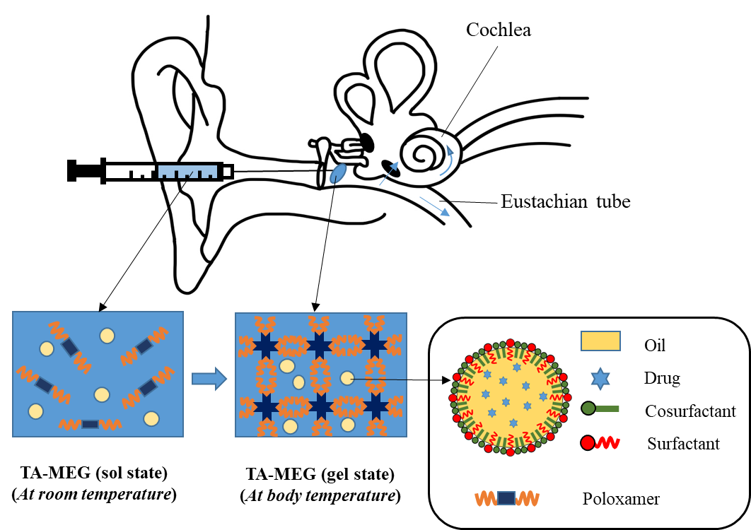

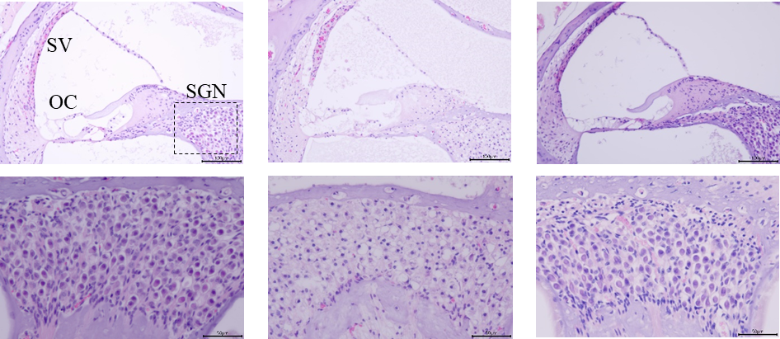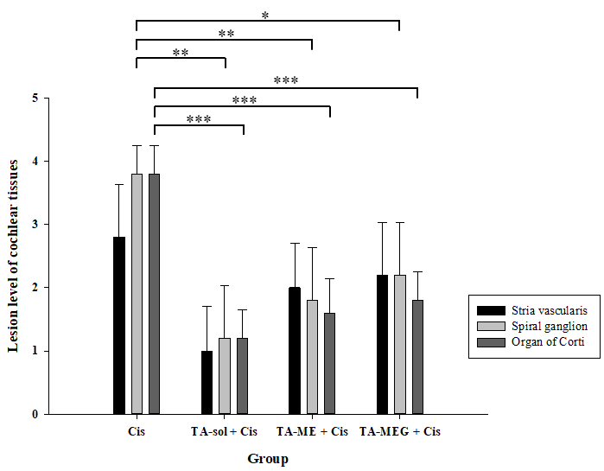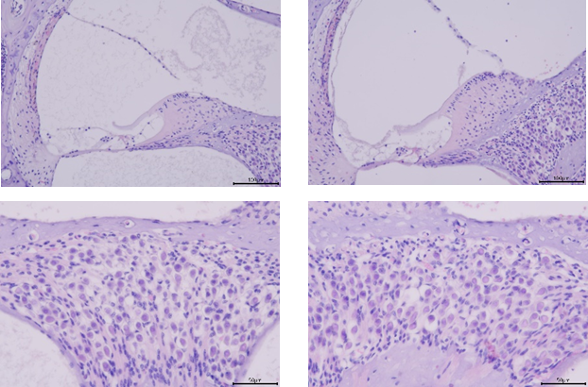

**Figure 1.** Illustration of key study insights.

**Figure 2.** *In vivo* oto-protective effect.

**Conclusion.** This study presents an injectable, biodegradable thermos-sensitive hydrogel for inner ear treatment. The temperature-induced gelation prolongs retention, and enhances drug absorption. Improved permeability across the round window membrane and sustained release for up to six days effectively protect cochlear structures from cisplatin-induced damage displayed by *in vivo* testing. This system holds promise for long-term drug delivery to the inner ear.

**References:**

(1) Dahm, V., Nieratschker, M., Riss, D., et al. (2019). Intratympanic triamcinolone acetonide as a treatment option for idiopathic sudden sensorineural hearing loss. Otolaryngology & Neurotology, 40(6), 720–727

(2) Han, Y. M., et al. (2021). Local drug delivery using poly(lactic-co-glycolic acid) nanoparticles in thermosensitive gels for inner ear disease treatment. Drug Delivery, 28(1), 2268-77.