ERRγ impedes neuroendocrine prostate cancer development
Ting LI^{1,2}. State Key Laboratory of Mechanism and Quality of Chinese Medicine¹, Institute of Chinese Medical Sciences¹; Ministry of Education Frontiers Science Center for Precision Oncology², University of Macau, Macao SAR, China.
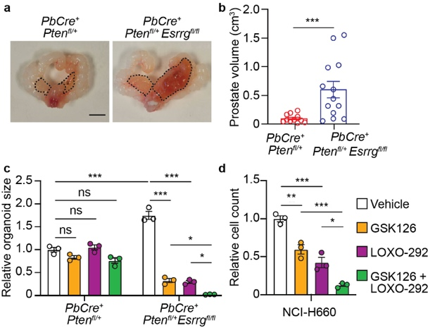
Introduction. Neuroendocrine prostate cancer (NEPC) is a lethal subtype of castration-resistant prostate cancer (CRPC) whose molecular drivers are incompletely understood and for which effective therapies are lacking. Here, we investigate the role of the nuclear receptor ERRγ in the adeno-to-neuroendocrine transition.
Aims. This study aimed to determine the functional role of ERRγ in NEPC pathogenesis and to exploit the resulting molecular insights for therapeutic discovery.
Methods. We employed a mouse model with Pten and ERRγ deficiency, mouse-derived organoids, advanced human cellular models, and xenografts. Techniques included genetic modulation of ERRγ, transcriptomic and metabolic profiling, ChIP-seq, and pharmacological inhibition using EZH2 and RET kinase inhibitors
Results. Loss of ERRγ drove neuroendocrine differentiation in the Pten-deficient mouse model and in human cancer cell models. Conversely, restoring ERRγ function reversed NEPC features, suppressed growth, and countered oncogenic metabolic reprogramming. Transcriptomic analysis revealed that ERRγ deficiency activates a neuroendocrine program, creating a vulnerability to combined inhibition of EZH2 and RET, which effectively blocked growth in ERRγ-deficient organoids and cells.
Discussion. Our findings establish that ERRγ downregulation facilitates prostate cancer transdifferentiation to NEPC. The resultant therapeutic vulnerability to co-targeting of EZH2 and RET offers a promising translational strategy for preventing or treating this aggressive disease.

