**Poly(2-oxazoline)s as a flexible platform for drug delivery**

*Jong-Ryul ParkA, Richard HoogenboomB, Tim R. DargavilleA*

AInstitute of Health and Biomedical Innovation, Queensland University of Technology, Brisbane, Australia; B Supramolecular Chemistry Group, Centre of Macromolecular Chemistry (CMaC), Department of Organic and Macromolecular Chemistry, Ghent University, Krijgslaan 281 S4, B-9000 Ghent, Belgium.

**Introduction.

Poly(2-oxazoline)s (PAOx) are a fascinating class of polymers receiving growing interest as biomaterials. Their applicability as biomaterials can be attributed to their similar physical properties to the ubiquitous polyethylene glycol (PEG) coupled with greater structural diversity and relatively easy synthesis. In some instances, e.g. protein resistance, PAOx has been shown to be superior to PEG.1 PAOx has also been explored for use in drug delivery as nanoparticles, polymer-drug conjugates, drug-eluting thermoplastics and hydrogels.2 In this paper the use of PAOx as a polymer-drug conjugate with self-modulating lower critical solution (LCST) properties and as hydrogels will be presented.

Results & Discussion.

Copolymers based on 2-propyl-2-oxazoline and 2-methyl butyrate-2-oxazoline were synthesized by cationic ring opening polymerization and conjugated with the ACE inhibitor drug, benazepril (**Fig 1**). Measurement of the cloud points in aqueous conditions revealed an interesting phenomenon of a shift in cloud point to higher temperature as the drug is cleaved. At body temperature the polymers form aggregates suggesting they may be useful as drug depots when injected, e.g. subcutaneously. As the drug is cleaved the aggregates disassemble and the polymer re-dissolves.

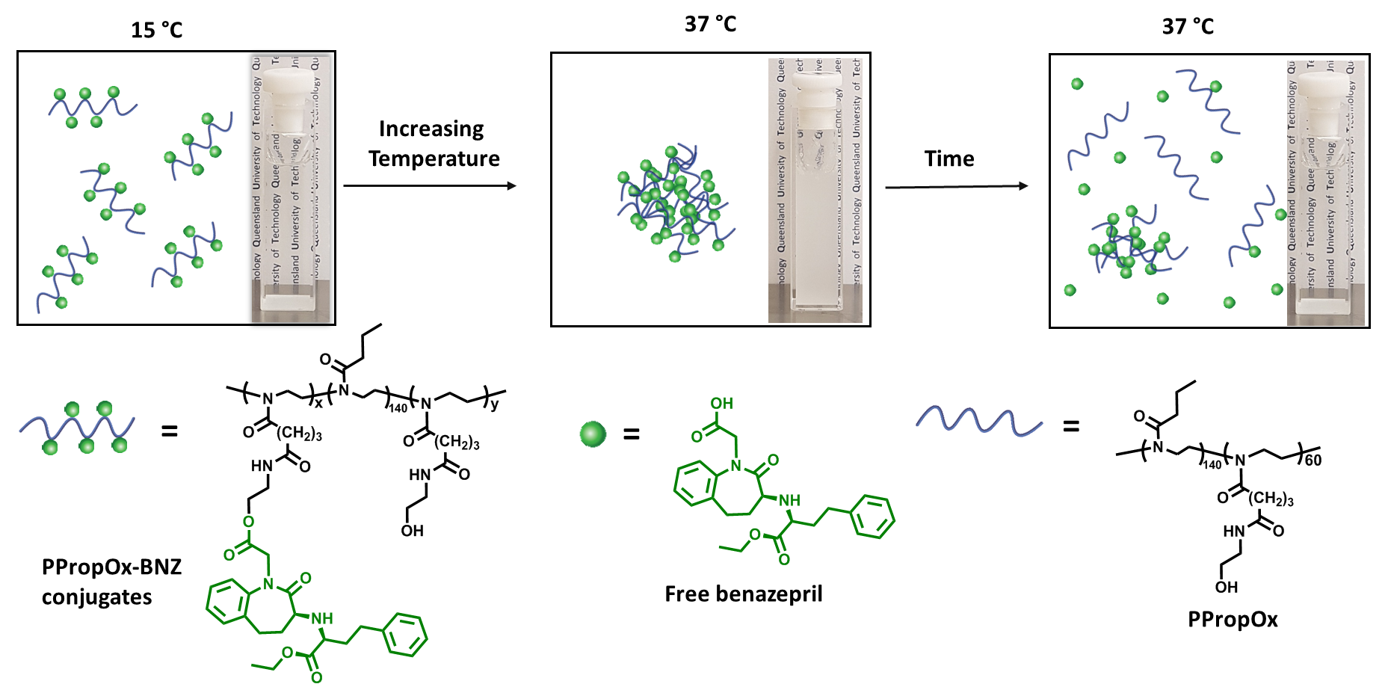

Figure 1: Poly(2-ethyl-co-propyl-oxazoline) conjugated with the drug benazepril shows LCST properties

Conclusion.

Polymer-drug conjugates based on poly(2-oxazoline)s have great potential in drug delivery applications such as ‘smart’ injectable materials with dynamic LCST.

**References**

1. R. Konradi, B. Pidhatika, A. Mühlebach, M. Textor, Langmuir 2008, 24, 613-616

2. TR Dargaville, J. Park, R. Hoogenboom Macromolecular Bioscience, 2018, 18, 1800070.

Corresponding author: Tim Dargaville [t.dargaville@qut.edu.au](mailto:t.dargaville@qut.edu.au)