Effects Of Arginine On Enhancing The Solubility Of Cannabidiol
Waiting Tai¹, Jonathon Carl Arnold^{2,3}, Hak-Kim Chan¹, Philip Chi Lip Kwok¹.
Advanced Drug Delivery Group, Sydney Pharmacy School, Faculty of Medicine and Health, The University of Sydney, NSW 2006, Australia¹;
Lambert Initiative for Cannabinoid Therapeutics, Brain and Mind Centre, The University of Sydney, NSW 2050, Australia²;
Discipline of Pharmacology, Sydney Pharmacy School, Faculty of Medicine and Health, The University of Sydney, NSW 2006, Australia³.

Background and aims. Cannabidiol (CBD) is a non-psychotropic cannabinoid with a promising therapeutic profile (1). However, its clinical application is significantly limited by its poor aqueous solubility at 1 µg/mL (2). To enhance the solubility of CBD in formulations, one potential strategy is to use amino acids as solubilisers. In particular, arginine has been reported to improve the solubility of various drugs (3, 4). However, it has not been studied for enhancing the solubility of cannabinoids. This study aims to investigate the effect of arginine on the solubility of CBD.
Methods. The shake flask method was used to determine the solubility of CBD. Briefly, 300 µL of 900 µg/mL CBD in 85:15 (v/v) methanol:water was transferred into an aluminium canister to load 270 µg CBD and vacuum dried. After adding 5 mL of phosphate buffered saline pH 7.4 with or without arginine, the suspensions were shaken continuously for 32 h in a shaking incubator at 37 °C and 150 rpm. Samples were then centrifuged for 10 min at 4255 x g at the same temperature. The supernatants were weighed into glass autosampler vials using stainless steel straws. The mass of the solution was taken to be equivalent to its volume as the density of the aqueous-based solution was effectively 1 g/mL. The solutions were vacuum dried at ambient temperature and reconstituted with 0.75 mL 130 µg/mL fluticasone propionate in 85:15 (v/v) methanol:water. Triplicate samples were prepared and quantified.
Results. The solubility of raw CBD in phosphate buffered saline was 1.0 ± 0.1 µg/mL. The addition of 10 mM and 40 mM arginine slightly increased CBD solubility to 1.2 ± 0.0 µg/mL and 1.4 ± 0.2 µg/mL, respectively. The saturated concentration of CBD increased to 2.4 ± 0.5 µg/mL at 200 mM arginine. Further increasing the arginine concentration to 255 mM and 280 mM enhanced CBD solubility to 3.4 ± 0.7 µg/mL and 5.2 ± 0.1 µg/mL, respectively. The increase in CBD solubility was linear between 0-255 mM arginine (r² = 0.95; Figure 1), with a positive deviation at 280 mM.
Conclusion/Discussion. Arginine significantly enhanced the solubility of CBD, potentially due to strong cation-π interactions between the positively charged guanidinium group in the side chain of arginine and the aromatic ring (resorcinol group) of CBD. A linear increase in CBD solubility was observed with increasing arginine concentration up to 255 mM. However, the positive deviation at 280 mM suggests the formation of higher-order CBD-arginine complexes. Future studies may consider the use of arginine as a solubiliser in cannabinoid formulation development.
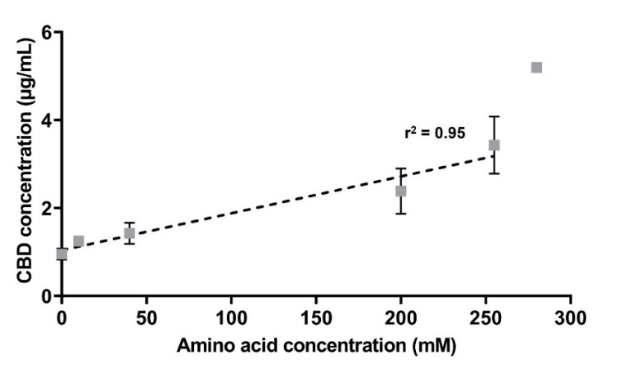
Figure 1. Phase solubility diagram of cannabidiol (CBD) with arginine. Data presented as mean ± standard deviation (n = 3). The dotted line represented the linear regression of CBD solubility between 0-255 mM arginine.

References:
- Yau, G.T.Y. et al (2023) Pharm Res 40(5):1087-1114
- Tai, W. et al (2025) AAPS PharmSciTech 26(5):120
- Alsalhi, M. S. et al (2022) RSC Adv 12(30):19040-19053
- Huang, Y. et al (2017) Pharm Dev Technol 22(1):69-76

