**Laser reduced graphene fundamentals and sensor application**

*Zhengfen Wan A,B, Shujun Wang A,B, Ben Haylock  C, Khoa-Nguyen Tuan  A, Hoang-Phuong Phan A, David Thiel B, Robert Sang C, Ivan S Cole D, Xiangping LiE, , Muhammad Umer  A,F, Muhammad J. A. Shiddiky A,F, Mirko Lobino A,C, Qin Li A,B\**

A Queensland Micro- and Nanotechnology Centre, Griffith University, Nathan, QLD 4111, Australia;

B School of Engineering and Built Environment, Griffith University, Nathan, QLD 4111, Australia;

C Centre for Quantum Dynamics, Griffith University, Nathan, QLD 4111 Australia;

D Advanced Manufacturing and Fabrication, RMIT University, Melbourne, VIC 3000, Australia;

E Institute of Photonics Technology, Jinan University, Guangzhou 510632, China;

F School of Natural Sciences, Griffith University, Nathan, QLD 4111, Australia.

Corresponding author: qin.li@griffith.edu.au

**Abstract**

The laser reduction method for graphene is a promising approach for manufacturing graphene-based devices such as supercapacitors, sensors and transistors, owing to its distinctive advantages in selective and localized reduction, direct micro- nanoscale patterning, and no requirement for chemicals. The graphene oxide film was irradiated and effectively reduced by a fs laser (780 nm). We systematically investigated and discussed the mechanism of this laser reduction process. It can be concluded that the two coexisting sub-processes during laser reduction, namely the direct conversion of sp3 carbon into sp2 carbon and the removal of oxygen can be tuned by adjusting the laser parameters. The different oxygen-contained groups can also be selectively reduced by controlling the power of laser. We further demonstrate the applicability of laser reduced graphene as strain sensor and biosensor due to its unique properties, such as large surface area and high conductivity. The strain sensors based on laser reduced graphene shows high sensitivity (gauge factor 52.5) in large strain range of 25.4% and good stability in 500 cycles. It was demonstrated to detect human motions such as folding and unfolding of wrist and fingers, showing its potential for artificial skin and wearable electronics. Moreover, the laser reduced graphene biosensor demonstrates good response and high sensitivity (10 fM) in RNA detection, showing strong potential for cancer detection and gene screening.

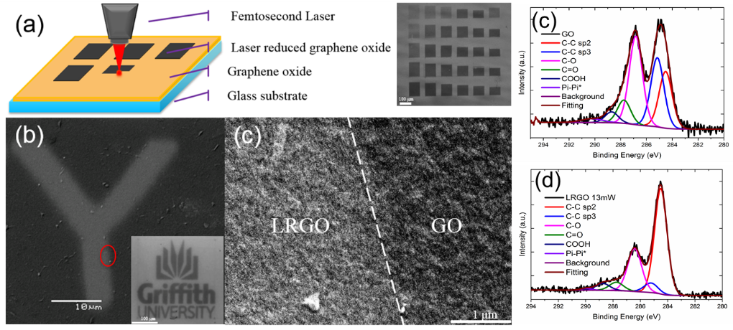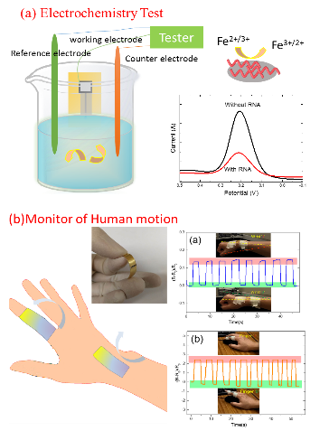

**References**

1. Wan Z, Streed EW, Lobino M, Wang S, Sang RT, Cole IS, et al. (2018). Laser-Reduced Graphene: Synthesis, Properties, and Applications. Adv. Mater. Technol., 1700315.
2. Wan Z, Wang S, Haylock B, Kaur J, Tanner P, Thiel D, et al. (2019). Tuning the sub-processes in laser reduction of graphene oxide by adjusting the power and scanning speed of laser. Carbon, 141, 83-91.
3. Li X, Ren H, Chen X, Liu J, Li Q, Li C, et al. (2015). Athermally photoreduced graphene oxides for three-dimensional holographic images. Nat. Commun.,6, 6984.
4. Z. Yang, D.Y. Wang, Y. Pang, et al. (2018). Simultaneously Detecting Subtle and Intensive Human Motions Based on a Silver Nanoparticles Bridged Graphene Strain Sensor. ACS Appl. Mater. Interfaces, 10(4), 3948-3954.