**Net Promoter Score Model for Evaluating Paediatric Medicine Acceptability: Validation and Feasibility Study**

Okhee Yoo 1,2,3, Demi Stanford 1, Britta S. von Ungern-Sternberg 2,3,4,5 and Lee Yong Lim 1,2,3

1Division of Pharmacy, School of Allied Health, The University of Western Australia, Perth, WA 6009, Australia; 2Institute for Paediatric Perioperative Excellence, The University of Western Australia, Perth, WA 6009, Australia; 3Perioperative Medicine Team, Perioperative Care Program, The Kids Research Institute, Perth, WA 6009, Australia; 4Division of Emergency Medicine, Anaesthesia and Pain Medicine, Medical School, The University of Western Australia, Perth, WA 6009, Australia; 5Department of Anaesthesia and Pain Medicine, Perth Children’s Hospital, Perth, WA 6009, Australia.

**Background and aims.** Medicine acceptability is crucial for paediatric drug development, yet its assessment remains challenging due to the multifaceted nature of sensory attributes like taste, smell, and mouthfeel. Traditional methods of acceptability evaluation often involve complex questionnaires and lack standardisation, leading to difficulties in a comparative analysis across studies. This study aimed to develop a simplified, standardised approach for assessing medicine acceptability introducing the Net Promoter Score (NPS, **Figure 1**) framework to derive a Medicine Acceptability Score (MAS).

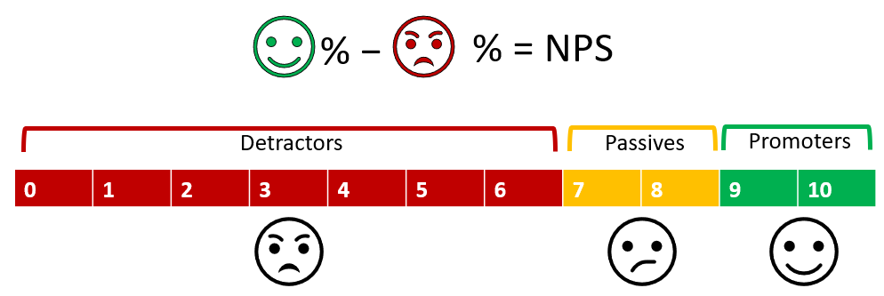

**Figure 1**. An illustration of how the Net Promoter Score (NPS) is calculated

**Methods.** A retrospective analysis was conducted using taste assessment data from nine paediatric formulations across four studies. The MAS was calculated by identifying an optimal range for categorising participant responses, which encapsulated diverse sensory attributes into a single metric. Validation was performed across various age groups and different formulations to test the reliability and discriminatory power of MAS.

**Results.** Taste-masked tablets (TMTs) generally showed higher median taste scores (3-4) and positive Willingness to Take Medicine Scores (WTMS) compared to liquid comparators (LQDs) which had lower median taste scores (1-2) and negative WTMS. A passive score of 3 (on a 5-point scale) yielded MAS values that best correlated with WTMS. Using this, TMTs with mean taste scores >3 had positive MAS (19 to 41), while LQDs (mean taste scores ≤2) had negative MAS. The MAS effectively discriminated between acceptable and unacceptable formulations, providing a practical tool for formulation development.

**Conclusion/Discussion.** This study highlights the impracticality of complex acceptability evaluations for multiple trial formulations in early development. Traditional metrics can be skewed by individual taste perception variability. The proposed Medicine Acceptability Score (MAS) offers a simpler alternative by quantifying the number of participants willing to accept a medicine (counting positive/negative responses, excluding neutral ones) rather than response intensity. MAS is a straightforward, practical tool for early-stage formulation optimisation.