**Bispecific TCR-directed Macrophage Engager (BiTME):**

**Harnessing Adaptive TCR Specificity and Innate Macrophage Cytotoxicity for Precision Immunotherapy of Immunosuppressive Solid Tumors**

**Jiaqi Zhao1**, Liqiang Pan1.

College of Pharmaceutical Sciences, Zhejiang University1, Hangzhou, Zhejiang, China;

**Background and aims.** Neoantigens presented as peptide-human leukocyte antigen complexes (pHLA) on malignant cells serve as precise targets for tumor immunotherapy. While T cell receptor (TCR)-pHLA binding enables intracellular mutation recognition, T cell-dependent cytotoxicity in solid tumors remains limited by infiltration barriers and functional exhaustion. Macrophages, however, exhibit tumor infiltrative capacity and microenvironment modulating potential. Here, we propose a bispecific TCR-directed macrophage engager (BiTME), which decouples TCR-pHLA recognition from T cell effector functions, utilizing macrophage homing capacity to penetrate tumor microenvironments (TME) and eliminate tumor cells through phagocytic activity.

**Methods.** BiTME was expressed in HEK293F cells. Functional activity was assessed via phagocytosis assays using human monocyte-derived macrophages. Bulk RNA sequencing was used to analyze transcriptomic changes and signalling pathways post treatment. In vivo antitumor efficacy was evaluated in NSG mice engrafted with exogenously infused human macrophages or PBMCs.

**Results.** BiTME effectively redirected macrophages to specifically eliminate neoantigen-expressing tumor cells, significantly enhancing tumor cell phagocytosis in vitro. Bulk RNA sequencing demonstrated enriched endocytosis and antigen presentation pathways in macrophages, with upregulated HLA-G transcripts. Notably, while membrane-bound HLA-G expression on tumor cells remained unchanged, macrophage surface HLA-G was downregulated. In contrast, soluble HLA-G levels were significantly elevated in co-culture systems. As HLA-G binding to ILT2/ILT4 receptors on immune cells suppresses antitumor immunity, combining BiTME with ILT2/ILT4 blocking antibodies further enhanced tumor killing. In tumor-bearing NSG mice reconstituted with exogenous macrophages or PBMCs, BiTME treatment demonstrated enhanced antitumor efficacy and prolonged survival.

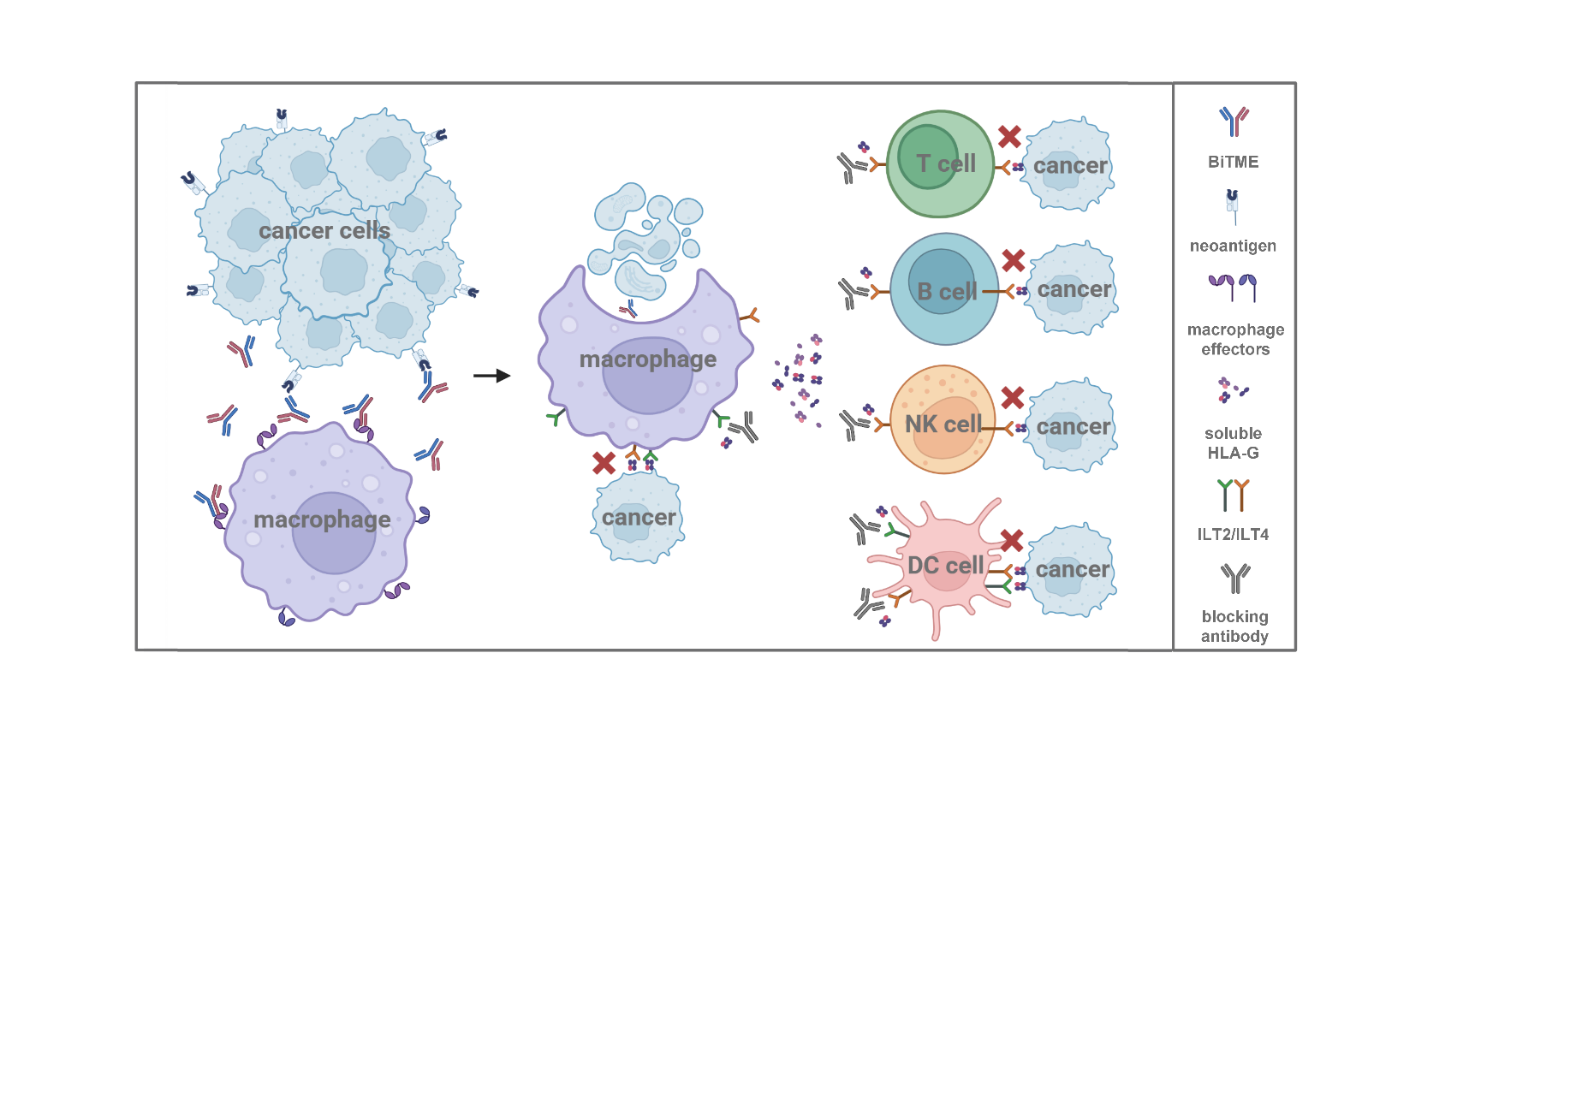

**Figure 1.** Mechanism of action of BiTME.

**Conclusion.** Genomic advances in high-throughput sequencing and machine learning empower precise neoantigen discovery. BiTME bridges intracellular neoantigen targeting with macrophage phagocytosis and TME remodelling, offering a multi-omics-integrated platform for resistant solid tumors. While preclinical models demonstrate therapeutic potential, clinical translation requires further validation of BiTME specificity and HLA-G/ILT axis modulation in autologous tumor settings. This study underscores personalised immunotherapy through genomic-driven macrophage engagement, aligning precision oncology with immune microenvironment reprogramming.

**References:** This work was supported by the research infrastructure and expertise of the Laboratory of Precision Medicine and Biopharmaceuticals, Zhejiang University.

(1) Jin, Shijie et al.Signal transduction and targeted therapy vol. 7,1 39. 7 Feb. 2022