Enhancing formulation stability of monoclonal antibodies with ionic liquids
Miftahus Saadah, Veysel Kayser. Sydney Pharmacy School, Faculty of Medicine and Health, The University of Sydney, Sydney, NSW, Australia.

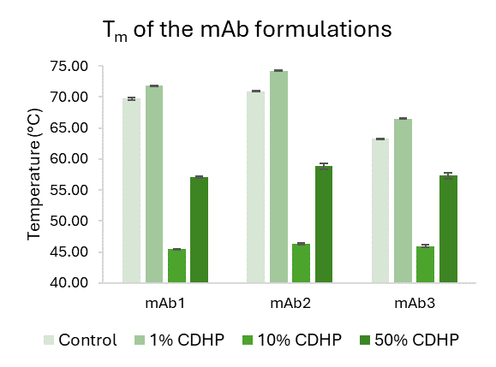
Introduction. Monoclonal antibodies (mAbs) are the most rapidly expanding class of biologics used for therapy and diagnosis. One of the significant challenges in mAb development is protein aggregation since it can lead to undesirable immunogenic reactions. Choline dihydrogen phosphate (CDHP) is a cholinium-based ionic liquid (IL) that has emerged as a promising candidate to produce stable biopharmaceutical formulations. Our group has been at the forefront of using ILs to improve mAb formulation stability. However, no research has been undertaken to evaluate how CDHP affects various mAbs. As a result, we evaluated CDHP's potential for stabilising a wide range of mAbs to prevent aggregation.
Aims. To investigate the impact of CDHP on various mAbs and determine the optimal concentration required to improve antibody stability against aggregation.
Methods. We prepared IgG1 (mAb1), IgG2/4 hybrid (mAb2) and IgG4 (mAb3) formulations with and without CDHP and tested their stability. Using different methods, we measured various characteristics to assess whether the IL approach can be broadly applied to stabilise mAbs.
Results. Adding 1% CDHP significantly increased the melting temperature (T_{m}) of mAb1 by 2.12 ± 0.15 °C (P<0.05), mAb2 by 3.32 ± 0.05 °C (P<0.05) and mAb3 by 3.30 ± 0.13 °C (P<0.05) compared to formulations without CDHP. Under accelerated studies at high temperatures, the monomer content of all mAbs with 1% CDHP was higher than that of mAbs without CDHP.
Discussion. These T_{m} improvements are crucial for long-term storage conditions, which are vital to prevent degradation products such as protein aggregation. This is critical for the immunogenicity and efficacy of mAbs, which ultimately affect the therapeutic outcome of the medicine. Higher monomer content suggests higher mAb stability as there are more mAb in monomers rather than dimers or oligomers.

