Thermoresponsive fluorinated PEG-based polymers/hydrogels
for monitoring drug release

Adil Usman^{A,B}, Cheng Zhang^{A,B}, Hui Peng^{A,B}, David J. T. Hill^{A}, & Andrew K. Whittaker^{A,B}

^{A}Australian Institute for Bioengineering and Nanotechnology, The University of Queensland, Australia
^{B}ARC Centre of Excellence in Convergent Bio-Nano Science & Technology

Thermoresponsive polymers are the most widely investigated of the stimuli-responsive polymers, due to their potential biomedical applications and their ease of control by stimulus (Vancoillie et al. 2014; Zhang et al. 2015). Many of these polymers undergo a phase transition at a certain temperature known as the lower critical solution temperature (LCST). PEG-acrylates are an exciting class of thermoresponsive polymers due to ease of polymerization and end group functionalization. Here we present the synthesis of PEG-acrylate based fluorinated polymers via free radical polymerization. By careful selection of monomer feed ratio, the LCST of the fluorinated polymers was brought down to physiological temperature. On cleavage of a hydrophobic model drug, the LCST is raised above the measurement temperature (T_{meas}) and the ¹⁹F MRI signal is “switched on”. These polymers were characterized in detail by ¹H and ¹³C NMR, SEC, UV-Vis spectroscopy and ¹⁹F magnetic resonance imaging.
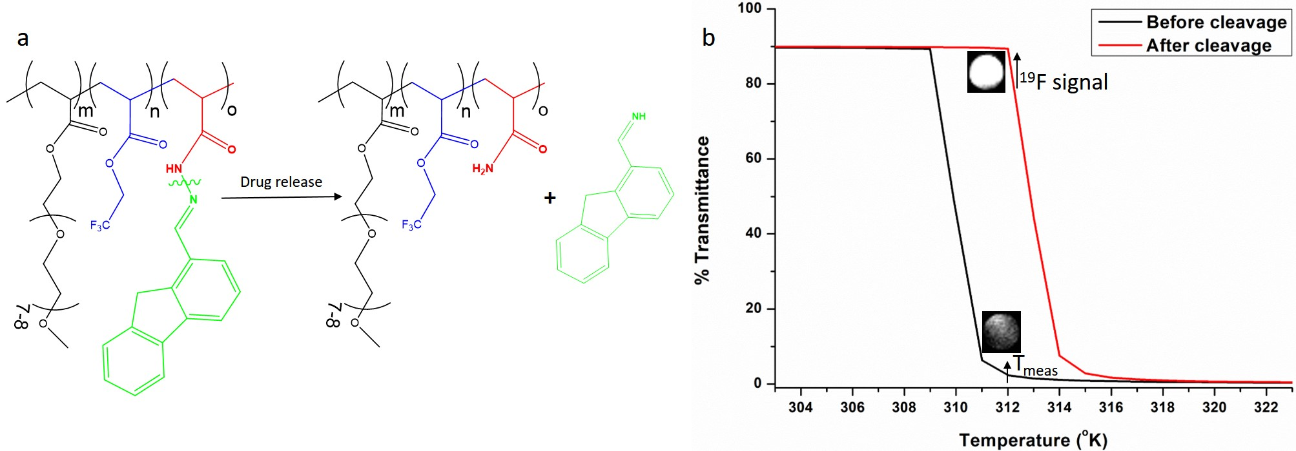
Figure 1 a) Structure of fluorinated PEG-based polymer and cleavage of hydrophobic drug, b) Cleavage of the hydrophobic drug, switches on the ¹⁹F MRI signal while the LCST of the fluorinated PEG-acrylate polymer shifts upwards.
References
Vancoillie, G.; Frank, D.; Hoogenboom, R. (2014). Thermoresponsive poly(oligo ethylene glycol acrylates). Prog. Polym. Sci., 39 (6), 1074-1095.
Zhang, C.; Peng, H.; Puttick, S.; Reid, J.; Bernardi, S.; Searles, D. J.; Whittaker, A. K. (2015). Conformation of Hydrophobically Modified Thermoresponsive Poly(OEGMA-co-TFEA) across the LCST Revealed by NMR and Molecular Dynamics Studies. Macromolecules., 48 (10), 3310-3317.

Email: a.usman@uq.net.au

