FPR2 agonist attenuates pulmonary arterial hypertension and right ventricular dysfunction in mice
Ting Fu¹, Chloe Landy¹, Yuchi Sun¹, Miles J De Blasio¹, Jaideep Singh¹, Anida Velagic¹, Owen L Woodman¹, Barbara Kemp-Harper², Peishen Zhao¹, Rebecca H Ritchie^{1,2}, Chengxue Qin^{1*}.¹Drug Discovery Biology and ²Department of Pharmacology, Monash Univ, VIC; Australia.

Introduction. Pulmonary arterial hypertension (PAH) is characterised by vascular remodelling, including intimal hyperplasia, fibrosis, and inflammation, which progressively increase pulmonary vascular resistance and vasoconstriction. The selective FPR2 agonist BMS-986235 enhances pro-resolving macrophage activity and improves cardiac remodelling post-myocardial infarction¹, but its therapeutic potential in PAH remains unknown.
Aim. To investigate the therapeutic effects of FPR2 agonist in preventing PAH progression.
Methods. Male C57BL/6J mice (9 weeks old) were allocated to normoxia (21% O₂) or sugen/hypoxia (SuHx, 10% O₂ plus weekly sugen 5416, 20 mg/kg) for 4 weeks. The SuHx cohort was randomly divided into three groups: (i) treatment-vehicle, (ii) BMS-986235 (3mg/kg/day), or standard clinical treatment (iii) sildenafil (0.3mg/kg/day). The normoxia cohort received the treatment-vehicle (10% DMSO in 0.8% Tween 80 in saline). At experimental endpoint, haemodynamics were assessed, and lungs and hearts were collected for histological and molecular analyses.
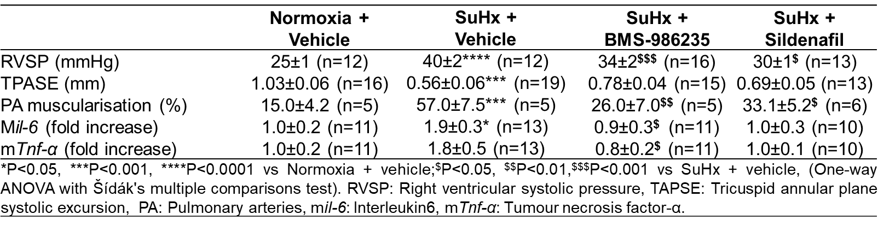
Results. SuHx mice displayed elevated right ventricular systolic pressure (RVSP), decreased tricuspid annular plane systolic excursion (TAPSE), complete muscularisation of small pulmonary arteries, and upregulated pro-inflammatory gene expression (mIl-6) in the lungs. BMS-986235 treatment reduced RVSP, increased TAPSE, limited pulmonary arterial muscularisation, and downregulated mIl-6 and mTnf-α expression, comparable to or exceeding the effects of sildenafil.
Discussion. Our study demonstrates that BMS-986235 lowers RVSP and limits vascular remodelling, similar to current clinical therapies, while additionally reducing inflammation and preserving RV function, highlighting its potential advantages beyond haemodynamic improvement.
^{1.} García, Ricardo A et al. (2021) JACC. Basic to translational science. doi: 10.1016/j.jacbts.2021.07.007

