Jet-Milled Nasal Dry Powder Inhalers for Enhanced Nose-to-Brain Delivery of Sumatriptan
Miseon Na¹, Heejun Park¹.
Pharmaceutical Research Laboratory, Department of Pharmacy, Duksung Women’s University, Seoul, South Korea¹.

Background and aims. Sumatriptan succinate (SS), a selective 5-HT1B/1D receptor agonist, is widely used for acute migraine therapy. However, its efficacy is limited by first-pass metabolism and the blood–brain barrier (BBB), delaying onset and reducing CNS drug delivery. Nose-to-brain (N2B) delivery offers a noninvasive route to bypass the BBB and enhance brain targeting. This study aims to design and optimize a dry powder inhaler (DPI) formulation of SS via jet milling (JM), guided by a design of experiments (DoE) strategy, to establish a viable platform for N2B delivery.

Methods. A 4:1 mixture of lactose and sumatriptan was blended with 1–10% MgSt or L-leucine and ground for 5 min. The mixture was jet-milled (Sturtevant Micronizer) under nitrogen at 600 kPa feed and 500 kPa grind pressure for 1 min. Processed powders were evaluated for size, morphology, crystallinity, and thermal stability using multiple analytical techniques.

Results. Among the tested lubricants, 5% magnesium stearate (MgSt) significantly improved powder flowability and reduced aggregation in the lactose–sumatriptan (4:1) mixture, as confirmed by SEM and PSD analysis. In contrast, L-leucine at higher concentrations led to particle agglomeration. DSC and PXRD analyses showed no polymorphic transformation after jet milling, indicating stable crystallinity. FT-IR and FE-SEM-EDS confirmed the absence of chemical interactions and the homogeneous distribution of components. The use of nitrogen gas and optimized milling pressures contributed to narrow particle size distribution suitable for nasal delivery.

Parameter | Value
Mixture ratio | 4:1 (LA:SS)
Lubricant type | MgSt or L-leucine
Lubricant content | 1%, 5%, 10%
Feed pressure | 600 kPa
Grind pressure | 500 kPa
Milling time | 1 minute
Gas used | Nitrogen (N₂)

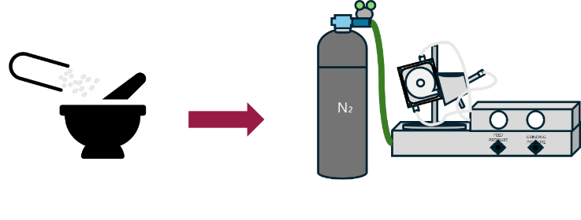

Figure 1. Schematic diagram of the jet milling process using nitrogen gas for DPI preparation. Table 1. Optimized conditions for jet milling process.

Conclusion/Discussion. Jet milling with MgSt (5%) significantly improved flowability and permeability of SS DPI formulations. PAMPA and cell assays showed enhanced mucosal absorption, with differences indicating distinct passive/active mechanisms. Optimized formulations offer strong potential for effective N2B delivery of migraine therapeutics.

Acknowledgements. This work was supported by the National Research Foundation of Korea (NRF) grant funded by the Korea government (MSIT) (No.2022R1C1C1010130). This work was supported by the Korea Basic Science Institute (National Research Facilities and Equipment Center) grant funded by the Korea government (MSIT) (No.RS-2024-00404864). This research was supported by the Technol-ogy Innovation Program (RS-2025-11572968), funded by the Ministry of Trade, Industry and En-ergy (MOTIE, Korea).

References:
(1) Puledda F. et al (2023) J Neurol 270:3654–3666.
(2) Tepper SJ. et al (2018) Med Devices (Auckl) 11:147–156.
(3) Sharif S. et al(2023) Pharmaceutics 15(2): Article 292.
(4) Chan HK. et al (2019) Int J Pharm 568:118504.

