**Multiple state thermally tunable metasurfaces**

*Khosro Zangeneh KamaliA*, Lei Xu, Andrey E. MiroshnichnkoB, Dragomir NeshevA, Mohsen RahmaniA*

ANonlinear Physics Centre, Australian National University, Canberra, Australia; BSchool of Engineering and Information Technology, University of New South Wales, Canberra, Australia.

**Introduction**

Metasurfaces are artificial and planar structures with sub-wavelength dimensions which can manipulate light characteristics, e.g., propagation direction, phase, intensity, etc. effectively. Dielectric metasurfaces are favored when compared to their metallic counterparts because of their lower optical absorption (Zangeneh Kamali *et al.* 2019). Moreover, the thermo-optical properties in dielectrics allow dielectric metasurfaces to be thermally tunable (Rahmani *et al.* 2018). Significant suppression of transmission can be easily achieved through metasurface at their resonance wavelength. This, along with the ability to tune the resonance wavelength of dielectric metasurfaces, bring the opportunity to control the transmission intensity of the light propagating through the metasurface. In this work, this concept has been employed to generate a thermally tunable binary image. It is worth mentioning that this technique is different from the other image formation techniques by metasurfaces, such as holograms which are based on controlling both phase and amplitude of the beam.

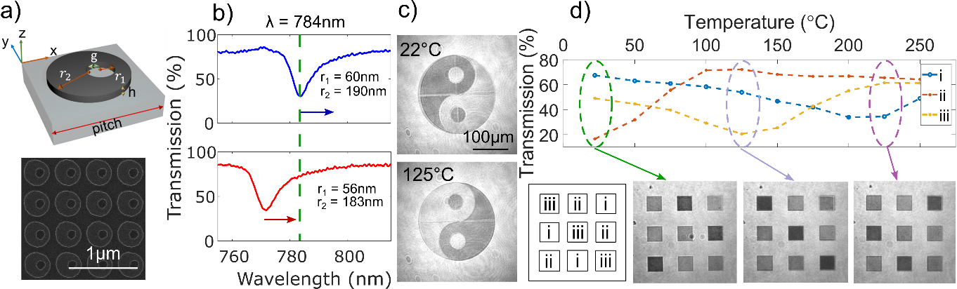

**Figure 1:** a) The SEM image of the metasurfaces along with the schematics of its unit cell b) The transmission spectra of two metasurfaces exhibit Fano resonance. Arrows show the direction of their shift by increasing the temperature c) The Yin-Yang image made of a metasurface at room temperature and 125˚C.

**Results and discussions**

**Fig. 1.** demonstrates our design and fabricated arrays of non-concentric disk-hole structures, which exhibit sharp Fano resonance (Jain et al. 2015). Slightly varying their dimensions can control the resonance wavelength of structures. Therefore, we have exploited these building blocks to generate a binary Yin-Yang image, consisting of two sets of metasurfaces that can exhibit sharp resonances around a wavelength of 780 nm (See **Fig.1b.**). As can be seen in **Fig. 1c.**, by fixing the imaging wavelength at 784 nm, we managed to inverse the contrast of the image by increasing the temperature of the sample. The mechanism for this phenomenon is the following: due to the large thermo-optic coefficient of the silicon, changing the temperature leads to changing the refractive index of the silicon resonators. As a result, the entire transmission spectra shift to a longer wavelength. By employing a sharp Fano resonance, this shift causes a drastic change in the transmission at the given wavelength of 784 nm. As shown in **Fig. 1c.**, by increasing the temperature, one building block experiences a decrease in transmittance, and the second one experiences a transmittance increase (Zangeneh Kamali *et al.* 2019).

**Conclusion**

In summary, we have demonstrated a novel technique for producing images with high contrast tunability by adjusting the temperature of the metasurface. We showed that by increasing the temperature of the metasurface and consequently shifting its resonance wavelength, we can tune the transmission intensity of the metasurface and construct images. The mechanism mentioned above brings an opportunity for metasurfaces to be used in a variety of application such as security holograms and encrypting messages in a more secure format.

**References**

1. Zangeneh Kamali, K., et al. (2019). Reversible image contrast manipulation with thermally tunable dielectric metasurfaces. Small., 15, 1805142
2. Rahmani, M., et al. (2017). eversible thermal tuning of all-dielectric metasurfaces. Adv Funct Mater., 27, 1700580
3. Jain, A., et al. (2015). Electric and magnetic response in dielectric dark states for low loss subwavelength optical meta atoms. Adv. Opt. Mater3, 1431–1438