Small molecule inhibition of DDAH1 reduces aggressive phenotypes of breast cancer cells
Belete K. Alemu¹, Jai Meyers¹, Julie-Ann Hulin¹, Sara Tommasi^{1,2}, Arduino A. Mangoni^{1,2}. College of Medicine and Public Health, Flinders Health and Medical Research Institute, Flinders Univ¹, Adelaide, SA; Dept of Clin Pharmacol, Southern Adelaide Local Health Network, Flinders Medical Centre², Adelaide, SA

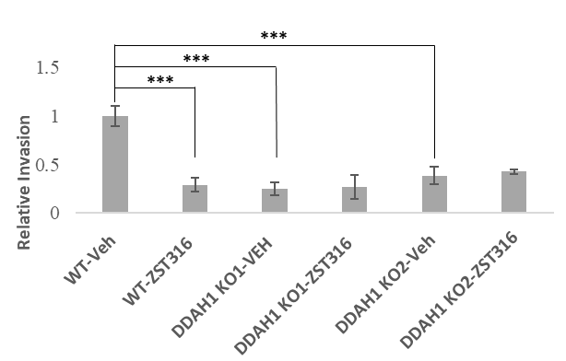
Introduction. DDAH1 regulates nitric oxide–dependent signalling linked to tumour cell proliferation, motility, metastasis, and vasculogenic mimicry (VM) in triple negative breast cancer (TNBC) cells (Hulin et al, 2019).
Aims. This study investigated whether ZST316, a potent in-house developed DDAH1 inhibitor, can modify the aggressive cell behaviour of TNBC cells with minimal off-target effects.
Methods. Control and DDAH1 knockout (KO) MDA-MB-231 cells were treated with 100 µM ZST316 or vehicle. Proliferation, migration, adhesion, and invasion assays were performed to evaluate anti-tumour effects, and transcriptomic and qRT-PCR analyses were conducted to assess changes in gene expression. Data are shown as mean ± SEM (n=4; p<0.001).
Results. ZST316 did not significantly affect proliferation compared with controls, although DDAH1 KO cells showed a significant decrease in basal proliferation. ZST316 significantly reduced migration and invasion in control but not KO cells, indicating DDAH1-specific effects of ZST316. In contrast, adhesion remained largely unaffected. Transcriptomic and qRT-PCR analyses revealed a limited number of differentially expressed genes in ZST316-treated control cells, with no change in DDAH1 expression.
Conclusion: DDAH1 enzymatic inhibition by ZST316 mediates suppression of cell motility and invasion, supporting the potential of DDAH1 as a therapeutic target to limit VM and, potentially, metastatic progression in TNBC.

Hulin et al (2019) Biomed Pharmacother 111:602-612

