Resveratrol versus curcumin: neuroprotective evaluation in an MPTP-induced Parkinson’s disease model
Rajendra Nath¹ ,Shalini Singh¹, Karan Suneja¹, Rishi Pal¹ , Department of Pharmacology and Therapeutics, King George’s Medical University¹, Lucknow, U.P., India

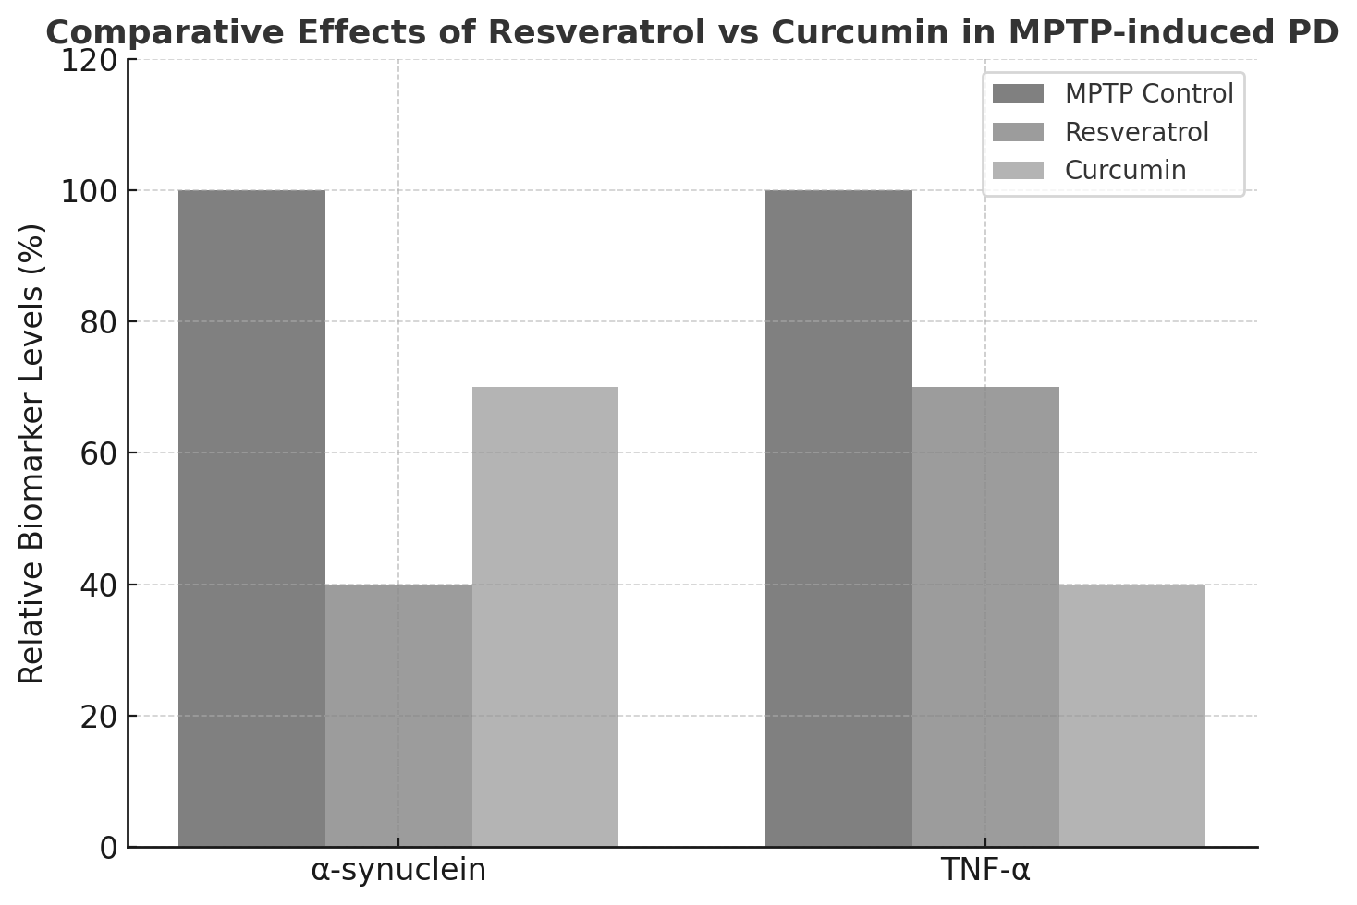
Introduction. Parkinson’s disease (PD), progressive neurodegenerative disorder marked by dopaminergic neuronal loss, α-synuclein aggregation, and neuroinflammation (Choong & Mochizuki, 2022). Although levodopa remains the standard symptomatic therapy, there is growing interest in natural polyphenols with potential disease-modifying properties. Resveratrol and curcumin possess antioxidant and anti-inflammatory activities but have not been extensively compared head-to-head for neuroprotective efficacy in PD.
Aims. To compare the neuroprotective effects of resveratrol and curcumin on α-synuclein and TNF-α levels in an MPTP (1-methyl 4-phenyl tetrahydropyridine) induced PD mouse model.
Methods. C57BL/6 mice were divided into four groups: normal control, PD control (MPTP 30 mg/kg intraperitoneal × 5 days), resveratrol (100 mg/kg oral × 30 days), and curcumin (60 mg/kg oral × 30 days). Brain homogenates were analyzed for α-synuclein and TNF-α using ELISA. Data were analyzed with one-way ANOVA, considering p < 0.05 significant.
Results. MPTP significantly elevated α-synuclein and TNF-α levels (Emamzadeh & Surguchov, 2018). Resveratrol and curcumin both reduced these biomarkers. Resveratrol showed stronger suppression of α-synuclein, while curcumin lowered TNF-α more effectively.
Discussion. Both agents showed neuroprotection but differed in their primary effects, with resveratrol acting more on protein aggregation and curcumin on inflammation. These results suggest complementary mechanisms and support future evaluation of combination therapy for disease modification in PD.
Choong CJ, Mochizuki H (2022) Neuropathology 42:93-103
Emamzadeh FN, Surguchov A (2018) Front Neurosci 12:612

