**Genetic advances in tackling emerging diseases of Faba bean (***Vicia faba* L**.) in Ethiopia**

Asnakech T.B. *1\**, Mussa J.*1*, Gemechu K. *1*, Sisay A. *1*, Mesfin T. *1*, Nigat T. *1*, Dereje A.*1*, Bereket A.*2*, Seid A.*3,* Barbetti M.J. *4 ,* You M.P. *4,* van Leur J. *5* Huttner E. *6*

*1Ethiopian Institute of Agricultural Research (EIAR)* *Holeta Agricultural Research Centre;*

*2Amhara Regional Agricultural Research Institute (ARARI) Debrebirhan Agricultural Research Centre;*

*3International Centre for Agricultural Research in the Dry Areas (ICARDA) Morocco*

*4University of Western Australia (UWA)*

*5New South Wales Department of Primary Industries (Australia)*

*6Australian Centre for International Agricultural Research (ACIAR)*

*Corresponding author: Asnakech T. Beyene: asnakechtek@yahoo.com

**Abstract**

*Faba bean (Vicia faba L.) is a crucial pulse crop for home consumption, income generation, and animal feed. It plays a key role in cereal-based rotation systems in the highlands of Ethiopia. However, sustainable production faces threats from an invasive disease called Faba bean Gall (FBG), caused by Physoderma viciae. The rapid spread of FBG in the cool highlands has significantly impacted production and biodiversity, also resulting in complete crop losses Collaborative efforts by EIAR, ICARDA, ARARI, UWA, and NSWDPI, through an ACIAR funded project, aims to manage the impact of the disease. Towards this outcome the epidemiology of Physoderma viciae is being defined. Importantly, the effective seed dressing chemical (Noble 25 WP), has been identified providing an immediate solution for farmers who had halted faba bean production. Largely, diverse faba bean genotypes from Ethiopia, ICARDA and Australia have been evaluated, leading to the identification of partially resistant genotypes for further evaluation.  Nevertheless, breeding of resistant varieties for faba bean gall requires the support of molecular tools to maximize identification of resistant genes for FBG disease and aggregate in popular cultivars. These molecular techniques play a crucial role in enhancing crop resilience and combating diseases.*

**Key words:** *Disease resistance, Faba bean; Molecular tools; Physoderma viciae, Resistance breeding*

**Introduction**

Faba bean (*Vicia faba* L.) is an important cool-season legume cultivated for human consumption worldwide, contributing to global food security and sustainable agriculture. Ethiopia is the secondary center of diversity for faba bean and ranks as the second-largest producer next to China, accounting for 18% of the world’s dry faba bean production (FAOSTAT 2022). Approximately 4.3 million smallholders cultivate faba bean on an area of 520,551.7 hectares, yielding about one million tons of grain with a national average productivity of 2.1 tons per hectare (CSA 2022). This crop plays a vital role in providing plant-based protein for human consumption, generating cash income, and serving as animal feed within the highland crop-livestock farming system. Additionally, faba bean contributes to soil fertility when used as a rotational crop in wheat and barley-based cropping systems.

Despite its importance, faba bean production in Ethiopia faces various biotic and abiotic challenges. Since 2010, an unidentified and highly destructive disease called Faba Bean Gall (FBG) has been reported and rapidly spread through farmers’ fields, resulting in significant yield losses. In some regions, this pathogen has caused up to 100% crop loss due to favorable environmental conditions, particularly in the highlands of Ethiopia (see Figure 1). Faba bean gall symptoms appear as sunken lesions on the upper side of leaves, which then protrude on the back side. These lesions gradually turn light brown and expand, eventually merging and causing necrosis of plant tissue. Affected plants become stunted and fail to produce seeds. The severity is more pronounced in higher-altitude growing areas with abundant precipitation and cool temperatures. Since 2018, Australian and Ethiopian scientists collaborated on an ACIAR-funded project with several key objectives: mapping the spread of Faba Bean Gall (FBG) disease in Ethiopia, identifying the true causal agent of FBG disease, studying the pathogen’s epidemiology, and exploring management strategies for FBG, including resistance breeding. The research involved laboratory and field work, utilizing distinct methodologies for each project activity

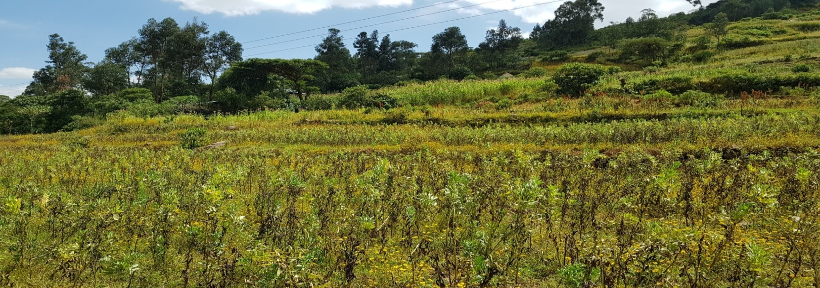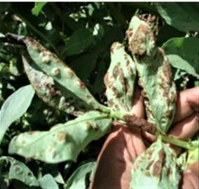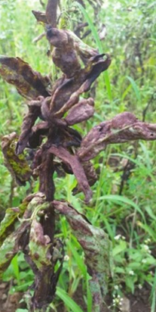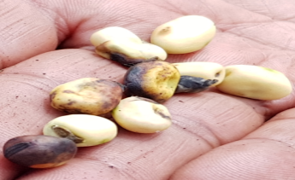

Figure 1: Faba bean field devastated by the faba bean gall disease in Northern part of Ethiopia;

**Result**

Morphological and molecular studies of the pathogen based on infected faba bean leaf samples from Ethiopian highlands, confirmed *Physoderma viciae* as the true FBG pathogen. Additionally, researchers identified primers for this pathogen, and ongoing studies focus on isolate diversity. Field pea, lentil, chickpea, Fenugreek, Trifolium Decorum, and Vetch (*Vicia sativa*, *V. dasycarpa, V. villosa*) have been found to be alternative hosts for the FBG pathogen. This pathogen spreads through infested soil, downhill run-off water, water splash, faba bean debris, and animal manure. Effective chemical treatments for controlling FBG have been confirmed in multiple trials; chemicals like Noble 25 WP as a seed dressing at a rate of 150 gm per 100 kg seed, Diprocon 33 EC, and Nativo SC 300 as spray applications. [These practices are now being scaled out to end-users as an immediate short term solution allowing farmers to continue growing faba bean.](https://languagetool.org/paraphrasing-tool)

[Numerous faba bean materials from various sources were assessed for resistance to faba bean gall disease under natural conditions, leading to the development of some tolerant materials](https://link.springer.com/article/10.1007/s00122-021-04022-7). An extensive evaluation of ninety-five faba bean materials sourced from the International Center for Agricultural Research in the Dry Areas (ICARDA), Australia, and the Ethiopian Biodiversity Institute (EBI) was conducted to assess their resistance to faba bean gall, chocolate spot, and *Ascochyta blight* at Mush for faba bean gall and at Holetta for chocolate spot in central highlands and Northern part of Ethiopia. Among all tested three genotypes AF14062, PBA Amberley and Ac1524#14003 showed less faba bean gall disease susceptibility as compared to other materials including the checks. Additionally AF14062 was found to be promising with low faba bean gall disease scores and even better in grain yield and other traits of interest. Similarly, genotypes 126183, Numan, Gora, Dosha, 5247, 5123, 126181, 106733, 5199, 5248, 106703, and Gebelcho PBA Zahra, CHNQ04-28-51, AF14075, Farah, Fiesta, CHNQ04-5-11, Ac1241#21910, and 11NF001a-10, showed promising results with low chocolate spot disease scores and superior grain yield. Notably, genotype AF14075 and the improved variety Nunam exhibited both good grain yield and resistance to chocolate spot diseases. However, future resistant breeding needs molecular tools for the identification and accumulation of resistant gene to ensure faba bean diseases varieties with effective resistance.

**Conclusion and recommendation**

Although there has been progress in chemical control and the identification of tolerant materials, additional advancements in resistance breeding require molecular tools to expedite the discovery and accumulation of resistance genes. [This will aid in developing faba bean varieties that are resistant to faba bean gall disease](https://languagetool.org/paraphrasing-tool).