**Combined bottom-up and top-down approaches in 3D printing**

*Rouhollah Ali Jalili*, Rose Amal*

School of Chemical Engineering, UNSW Sydney, NSW 2052 Australia

*Email address: ali.jalili@unsw.edu.au

Additive manufacturing also known as 3D printing is enabling production of structured functional materials and has the potential to close the gap between discoveries and manufacturing by providing an effective path toward favorable device cost and performance. Central to many promises of 3D printing is to overcome the limitations of conventional device productions to allow freedom of design and provide new functionality while substantially lower the materials cost and energy. Although, additive manufacturing is coined as the revolutionary manufacturing technique of choice, by mimicking nature’s pathway in creating functional systems, perhaps the most important neglected aspect which severely overshadows its promises is the lack of a platform to bridge the gap between the nano-world to the macro-world, which nature elegantly executes. This calls for the convergence of typical 3D printing techniques with resolution at molecular level to effectively exploit the nanoscale properties of individual building blocks in the final architecture. If this achieved, 3D printing can be effectively used to print complex multifunctional electrodes containing both scaffolding and active materials for batteries, supercapacitors and electrocatalysis applications.

Biological systems implement anisotrpic molecular building blocks and their remarkable self-assembling properties to achieve liquid crystal mediated complex structural arrangements and patterns. Following this model, we formulate a range of liquid crystal mediated composite inks employing anisotropic properties of super-flexible two-dimensional giant graphene oxide (GO) (*1*) and active materials building blocks in water for 3D printing complex self-oriented scaffold electrodes (Figure 1). We found, upon the addition of even trace amounts of large 2D sheets of graphene oxide to the printing inks, we could form a self-assembled printing ink exhibiting a percolating active network resembling cytosystem dynamics. Our observations exemplify how we can take advantage of anisotropic building blocks in traditional 3D printing processes to fully unlock the potential of individual constituent phases to print macroscopic functional architectures following the nature’s footpath.

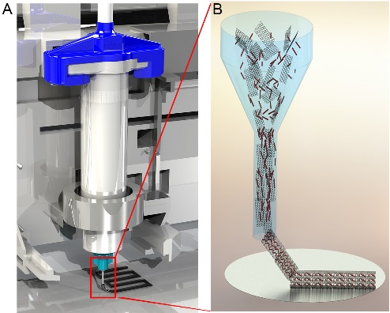

Figure 1. Schematic illustration of the 3D printing process of self-oriented electrodes.

**References**

1. P. Poulin *et al.* (2016). Superflexibility of graphene oxide. Proc. Natl. Acad. Sci.  113, 11088-11093.