**Drug-Drug Interaction between Trastuzumab Emtansine (T-DM1) and Orally Administered Tacrolimus in a Patient and in Rat**

**Yoshimichi Sai1,2**, Tomohiro Nakamura1, Moeko Shimada2, Makiko Takabayashi2, Arimi Fujita1,2, Takahiro Kawakami1,2, Hiroyuki Maruyama3，Hirofumi Terakawa4, Tsutomu Shimada2,5, Toshihiro Miyamoto3, Takahiro Ishimoto1,2.

Department of Clinical Pharmacokinetics1, Department of Hospital Pharmacy2, Department of Hematology3,Department of Breast Surgery4, Department of Clinical Pharmacy and Healthcare Science5, Kanazawa University, Kanazawa, Ishikawa, Japan.

**Background and aim.** Trastuzumab emtansine (T-DM1) is an antibody-drug conjugate (ADC) composed of trastuzumab (Tmab) and N2'-deacetyl-N2'-(3-mercapto-1-oxopropyl)-maytansine (DM1), a cytotoxic drug (payload). Compared to small molecule drugs, ADCs are considered less likely to interact with metabolic enzymes such as CYPs or drug transporters. However, we have experienced a 2.3-fold increase in the trough concentration of orally administered tacrolimus in a patient for 7 days after intravenous administration of T-DM1. The aim of this study was to confirm and clarify the mechanism of this drug-drug interaction using rat model.

**Methods.** We conducted a detailed retrospective clinical study of the interaction between T-DM1 and tacrolimus in this case and conducted animal experiments using rats to examine the putative pharmacokinetic interaction.

**Results.** Retrospective clinical study revealed no change in factors known to alter the pharmacokinetics of tacrolimus, and the change in the trough concentration of tacrolimus was reversed after switching T-DM1 to trastuzumab (Tmab). Thus, interaction with T-DM1 was suspected as the cause of the increased trough concentration of tacrolimus. An animal study in rats showed that T-DM1 significantly increased the AUC0-∞ of orally administered tacrolimus by more than 2-fold on day 0, day 3, and day 7, whereas no change was observed in the case of intravenous administration of tacrolimus. T-DM1 also significantly increased Fa・Fg of tacrolimus by more than 2-fold on day 7. In contrast, Tmab itself had no effect on the blood concentration of tacrolimus. These results suggest that T-DM1 increased the blood concentration of orally administered tacrolimus, and the effect persisted for 1 week after T-DM1 administration.

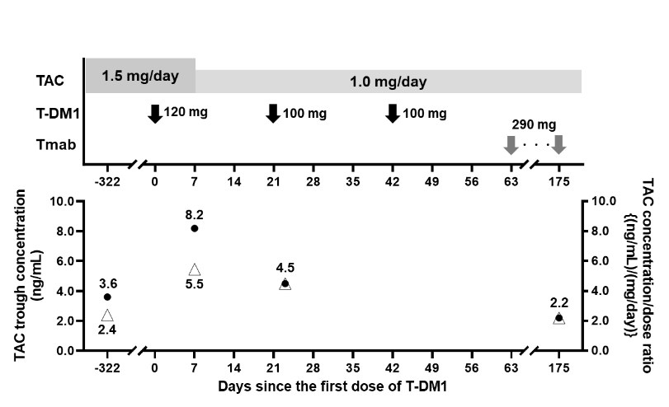

**Figure 1.** Clinically administered doses of tacrolimus (TAC), T-DM1 and trastuzumab (Tmab), trough concentration of tacrolimus (●), and concentration/dose (C/D) ratio of tacrolimus (△)

The patient was taking tacrolimus (1.5 mg/kg or 1.0 mg/kg) orally and then T-DM1 (120 mg or 100 mg) or Tmab (290 mg).

**Conclusion/Discussion.** An increase in the blood concentration of orally administered tacrolimus was observed after intravenous T-DM1 administration in a patient and the interaction was confirmed in an animal study. It is known that T-DM1 is metabolized and the metabolites predominantly undergo biliary excretion. It was suggested that metabolites of T-DM1, rather than Tmab itself, affected the gastrointestinal absorption of tacrolimus.

**Acknowledgements:** This work was supported in part by JST SPRING [Grant Number JPMJSP2135] and JSPS KAKENHI [Grant Number JP23K06209].