**Mixed Nano-micelles Promotes Therapeutic Efficacy in Glioblastoma**

**Mohammad Nasri1**, Naomi K Sia1, Rebecca H Roubin1, Pegah Varamini1.

Sydney Pharmacy School, University of Sydney1, Sydney, NSW, Australia

**Background and aims.** Glioblastoma (GBM) remains a formidable therapeutic challenge due to its aggressiveness and impermeability of blood–brain barrier (BBB). This study aimed to use nanomedicine and develop mixed micelle-based nanoparticles (MM-NPs) using Pluronic F127 and D-α-tocopheryl polyethylene glycol succinate (TPGS) to enhance the delivery and cytotoxicity of lipophilic anti-cancer agents -curcumin (Cur) and ursolic acid (UA)- in GBM cells. TPGS holds a growing usage in drug delivery, due to its ability to overcome multidrug resistance in cancer cells, and mediate transport of drugs across the BBB. Alendronate (Aln) was tested for synergistic therapeutic effects.

**Methods.** MM-NPs were prepared via film hydration and characterized for particle size, zeta potential, polydispersity, drug loading (DL), and encapsulation efficiency (EE). Cytotoxicity and cellular uptake of curcumin or UA-loaded MM-NPs conjugated or non-conjugated with Aln were assessed in vitro using human U87MG GBM cells, along with normal breast epithelial cells (MCF-10A), and triple-negative breast cancer cells (MDA-MB-231). MTT assays and IncuCyte were used to assess cell viability.

**Results.** Curcumin-loaded MM-NPs showed favorable physicochemical properties (∼30 nm size, ∼6% DL, ∼60% EE) and enhanced aqueous stability, especially with Aln-conjugation. UA-loaded MM-NPs exhibited poor loading (<1%). Cur-MM-NPs significantly reduced U87MG cell viability (IC₅₀ ∼ 9 µM), outperforming temozolomide (IC₅₀ > 1000 µM). Interestingly, Void-MM-NPs also showed selective cytotoxicity toward cancer cells, attributable to the TPGS component, while sparing normal cells. No statistically significant advantage was observed with Aln conjugation in cytotoxicity.

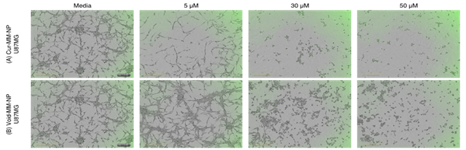

**Figure 1.** IncuCyte images of human U87MG glioblastoma treated for 48h with only media (control) or different concentrations of Cur-MM-NP and Void-MM-NP.

**Conclusion/Discussion.** This study demonstrates that MM-NPs, especially those incorporating TPGS, can serve as dual-function nanocarriers for GBM cells. These findings highlight MM-NPs as promising candidates for multimodal GBM therapy, meriting further investigation in in-vivo models and mechanistic studies.

**References:**

(1) Bhattacharya, S. et al (2025) Current Medicinal Chemistry

(2) Keshavarz S, S. et al (2024) JDT 32(10):1207-1232