**Development and Validation of A High-Performance Liquid Chromatography Method for the Simultanous Quantification of 17β-Estradiol, Testosterone, and Melengestrol Acetate in Simulated Biological Samples**

Anh HV Vu1, Anh TL Nguyen2, Trang T Pham1, Tuyen T Nguyen1, **Thuan TM Nguyen1**

Department of Biochemistry, Faculty of Pharmacy, University of Medicine and Pharmacy at Ho Chi Minh City1, Ho Chi Minh City, Viet Nam

Institute of Public Health Ho Chi Minh City2, Ho Chi Minh City, Viet Nam

**Background and aims.** 17β-Estradiol (E2), Testosterone (TE), and Melengestrol acetate (MGA) are hormones commonly used to promote growth in livestock. The residus of these hormones in food can cause many health risks. The objective of this study was to develop a HPLC-PDA method to determine these steroid hormones in simulated biological samples.

**Methods.** 17α-methyltestosteron as internal standard (IS) and three steroid hormones were extracted from simulated biological samples by a mixture of ethyl acetate:methanol (7:3, v/v). 10 µL of extracts were injected onto Thermo Scientific Hypersil™ ODS C18 column maintained at 27°C on a Waters 2695 XE equipped with a PDA detector set at 278nm for E2; 244nm for TE and IS, and 290nm for MGA. The mobile phase consisted of a mixture of acetonitrile:methanol:water (20:57:23, v/v) set at a flow rate of 1 mL/min. The validation criteria were evaluated according to FDA guidelines 2022.

**Results.** Total run time was 10 minutes. The retention times for E2, TE, IS, and MGA were 4.5; 6.1; 5.7 and 7.5min, respectively. Linearity ranged from 0.25-50ppm for E2, from 0.1-50ppm for TE and MGA. Mean intra-day and inter-day imprecision for E2, TE, and MGA were below 15%. LLOQ was 0.25ppm for E2, and 0.1ppm for TE and MGA. The stability study displayed the degradation of steroid hormones below 15% after 24 hours at RT.

**Table 1.** Intra-day and inter-day accuracy and imprecision, and recovery for E2, TE, MGA at 4 levels of Quality Control (QC) samples



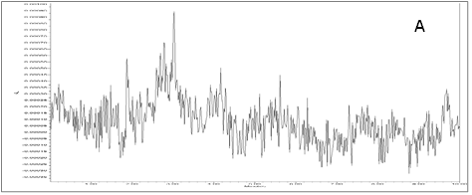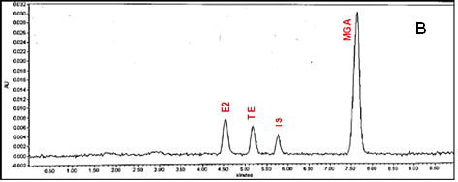

**Figure 1.** Chromatogram of extracts from (A) blank sample (placebo) and (B) stimulated biological sample reconstituted with steroid hormones and IS (10 ppm)

**Conclusion/Discussion.** We validated a rapid. simple. accurate and reliable procedure for simultaneous quantification of E2, TE and MGA. This analytical method could be used to clinical trials and assess the toxicity of these hormones.

**References:**

(1) Snoij TE. Hormon in Food as a Potential for Human Reproductive and Health Disorders. Acta Veterinaria. 2019;69:137-152.

(2) Galbraith H. Hormon in international meat production: biological, sociological and consumer issues. Nutr Res Rev. 2002 Dec;15(2):293-314.

(3) Codex Alimentarius Commission. Maximum residue limits (MRLs) and risk management recommendations (RMRs) for residues of veterinary drugs in foods. 2018:21-29.

(4) U.S. Food and Drug Administration. M10 Bioanalytical Method Validation and Study Sample Analysis: Guidance for Industry. U.S. Department of Health and Human Services; November 2022.