**Week-long Normoglycemia in Diabetic Mice and Minipigs via a Dose of Glucose-responsive Insulin Complex**

**Juan Zhang1**, Jinqiang Wang1, Zhen Gu1.

School of Pharmacy, Zhejiang University1, Hangzhou, Zhejiang Province, China.

**Background and aims.** The treatment of insulin therapy for diabetics is burdensome due to daily multiple subcutaneous injections. It also carries risks of frequent hyper- and hypoglycemia. PBA-based glucose-responsive carriers mimic β-cell function by dynamically releasing insulin in response to blood glucose. However, it remains a challenge to regulate blood glucose levels for longer than one week after a single dose.

**Methods.** Recombinant human insulin was covalently modified with gluconic acid to generate an insulin analogue with diol moiety (Glu-insulin). Glu-insulin can form a stable complex with 4-carboxy-3-fluorobenzeneboronic acid (FPBA)-modified poly-ʟ-lysine (PLL-FPBA). The glucose-responsive insulin release performance was tested in vitro and in vivo. Pharmacokinetics and pharmacodynamics were evaluated in type 1 diabetic mice and minipigs. The toxicity and the fibrous capsule-resistant capability of PLL-FPBA was evaluated.

**Results.** The insulin complex in a 400 mg/dL glucose solution achieved unbound Glu-insulin levels over two-fold higher than those observed in the 100 mg/dL glucose concentration. In type 1 diabetic mice, the complex maintained blood glucose below 200 mg/dL for over one week at a dose of 20 mg/kg. Following intraperitoneal glucose administration, the complex restored blood glucose to normal levels within two hours, even 12 days post-injection. The complex also normalized blood glucose for over 120 hours in type 1 diabetic minipigs. Both models showed negligible hypoglycemia. PLL-FPBA was gradually eliminated with negligible toxicity to the liver and kidney and almost absent fibrious capsule under the skin.

**Conclusion.** The subcutaneously injected glucose-responsive formulation intelligently senses blood glucose fluctuations and dynamically regulates insulin release. It avoids fibrous capsule formation and achieves week-long normoglycemia with negligible hypoglycemia in type 1 diabetic mice and minipigs. Its therapeutic efficacy as a long-acting single-dose agent supports further translational evaluation.

**References:**

(1) Sun, H. et al. (2022) Diabetes Res Clin Pract 183:109119

(2) McCall, A.L. (2012) Endocrinol Metab Clin 41:57-87

(3) Wang, J. et al. (2019) Sci Adv 5:eaaw4357

(4) Yu, J. et al. (2020) Nat Biomed Eng 4:499-506

**Figure 1.ZHANG_Fig 1 Figure 2.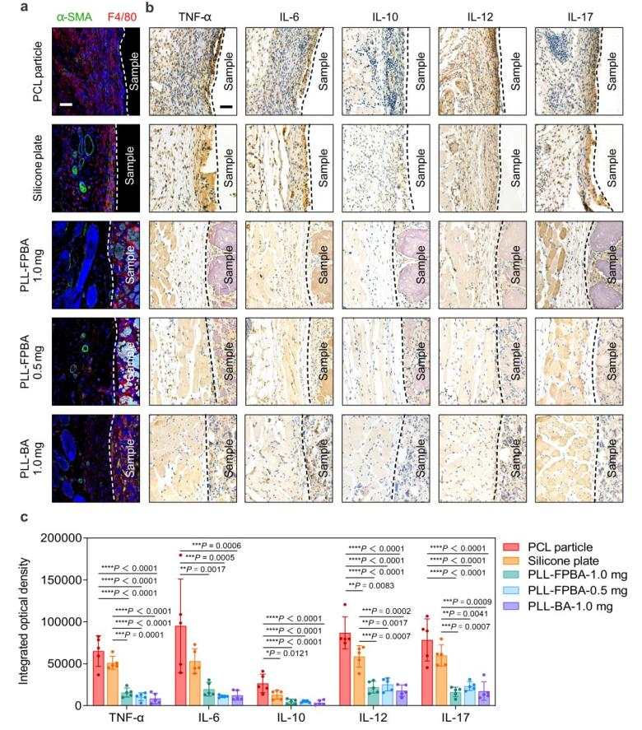**

**Figure 1. In vitro/in vivo validation of glucose-responsive behavior and PD/PK of the complex**

**a**, Schematic. **b**,**c**, SEM and TEM images. **d**, In vitro glucose-responsive insulin release. **e**, Blood glucose of diabetic mice. **f**, Glucose-triggered insulin release in mice. **g**, Long-term therapeutic effect. **h**,**i**, PD/PK profiling in diabetic minipigs with one injection. **j**, Glucose-triggered insulin release.

**Figure 2. Inflammation and fibrosis evaluation of the complex**

**a**, Immunofluorescence staining of macrophage biomarker (F4/80, red) and α-smooth muscle actin (α-SMA, green). Scale bars, 50 μm. **b**, Immunohistochemical staining of TNF-α, IL-6, IL-10, IL-12, IL-17. Scale bars, 50 μm. **c**, Integrated optical density within 100 μm around the implants.