**Electrospun zein nanofibrous membranes decorated with metal organic frameworks for formaldehyde adsorption**

*Yen Bach Truong, Liam Ayaden and George Maurdev*

CSIRO Manufacturing, Research Way, Clayton, Victoria 3168.

**Abstract**

Indoor pollution poses a serious threat to human health, it is generally recognised that Australians spend 90% or more of their time indoor so research in new materials to improve indoor air quality is warranted. Typical air pollutants are either solid/liquid aerosols or gas molecules. Aerosols, also known as particulate matter (PM), have been further classified, based on the inhalable particle size, as PM 10 (2.5−10 μm), PM 2.5 (0.1−2.5 μm) and PM 0.1 (<0.1 μm); gaseous pollutants include volatile organic compounds (VOCs). Aerosols and VOCs are both a result of man-made activities such as industrial processes, vehicle emissions, and indoor activities like cooking. For example, both old and new building materials, paints, and furniture are a source of VOCs such as formaldehyde and xylene [1]. Formaldehyde, one of the most common volatile organic compounds (VOCs) is a colourless gas and has been classified as a human carcinogen that may cause nasopharyngeal cancer and leukemia [2].

Metal organic frameworks (MOFs) are composed of metal ions/clusters and organic ligands which have been demonstrated as suitable candidates for air pollution control because of their unique properties, such as large surface area and rich functionalities [2]. Electrospinning is a scalable fabrication technique that produces nanofibrous membrane with fibres having diameter ranging from 50 nm to 1 µm that can be used to produce filter media with excellent aerosol filtration efficiencies [1].

The approach in this current study combines a scalable and low-cost method for fabricating flexible metal organic framework decorated-nanofibrous flexible filter media, thus providing an ideal passive filter media that can be part of indoor furnishing. This research goal will be achieved by

1. Producing a stable electrospun zein (corn protein) nanofibrous membrane,
2. Decorating the zein nanofibrous membranes with metal organic frameworks and
3. Characterizing and testing for formaldehyde adsorption performance

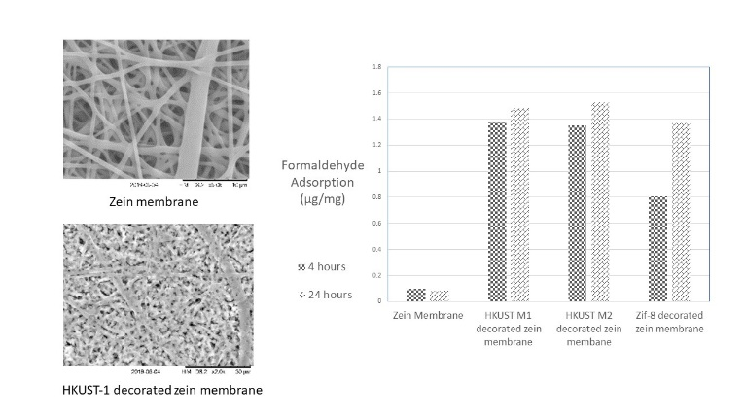

It was possible to fabricate electrospun zein membrane and then to decorate them with HKUST-1 and ZIF-8 as shown in the SEM images.

Testing revealed that zein membrane alone does not adsorb formaldehyde, but the MOFs decorated zein membranes do at different rates.

**References**

1. Kadam V, Truong YB, Easton C, Mukherjee S, Wang L, Padhye R, Kyratzis IL (2018) Electrospun Polyacrylonitrile/β-Cyclodextrin Composite Membranes for Simultaneous Air Filtration and Adsorption of Volatile Organic Compounds. ACS Applied Nano Materials 1 (8):4268-4277.
2. Bian, Y., Wang, R., Wang, S., Yao, C., Ren, W., Chen, C., et al. (2018). Metal-organic framework-based nanofibres filters for effective indoor air quality control J. Mater. Chem. A, 2018, 6, 15807-15814