Assessing Metronidazole and Tinidazole for Anaerobic Infections: A Case-Control Study
Pawar Vaishnavi Bharat¹, A S Kamakshi Shriya², Harish Kumar*. Department of Surgery, JSS Hospotal¹, Mysuru, Karnataka (KA), India; Department of Clinical Pharmacy.

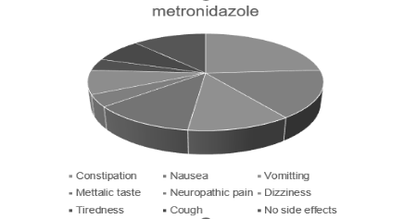
Introduction. Metronidazole and Tinidazole are broad-spectrum antibiotics for anaerobic and protozoal infections. They offer varied safety profiles. Metronidazole, though widely used, poses side effects. Tinidazole emerges as a promising alternative with fewer adverse effects and high bioavailability. This study assesses their effectiveness in treating anaerobic infections of the foot and gut.Metronidazole was often prescribed for gangrene, while tinidazole was for cellulitis. Treatment duration varied by diagnosis.
Aims. To compare the safety, efficacy, and adverse reactions of metronidazole and tinidazole in treating anaerobic infections, addressing research gaps.
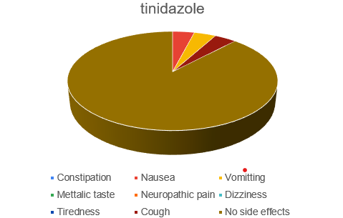
Methods. A case-control study was carried out at a surgical department in a multi-specialty hospital over five months, from September 2023 to January 2024. Patients over the age of 18 prescribed either metronidazole or tinidazole were included, following approval by the Institutional Human Ethics Committee. The study utilized comprehensive Informed Consent and Data Collection Forms.
Results. Fifty patients, evenly split between metronidazole and tinidazole, with an average age of 50.45±16.67 years, primarily in the 45-63 age range, were studied.ADRs were more frequent with metronidazole, primarily constipation. Naranjo's scale indicated most ADRs as "probable," while the WHO scale classified tinidazole-induced ADRs as "possible."
Discussion. Studies found 50% of patients experienced ADRs, with a higher prevalence in metronidazole compared to tinidazole. Tinidazole has proven to be an effective choice with a 80% cure rate. ADRs included constipation, nausea, vomiting, metallic taste, neuropathic pain, dizziness, tiredness, and cough with metronidazole, and nausea, vomiting, and cough with tinidazole. Nausea predominated and was likely caused by the drugs. Neuropathy occurred in one case with metronidazole. Smoking and alcohol intake didn't significantly influence ADRs.
Conclusion. Metronidazole and Tinidazole demonstrate varying efficacy and safety profiles in treating anaerobic infections, with Tinidazole showing potential as a safer alternative.

