Pharmacological investigation of 5-HT effects on the isolated porcine urethra
Eriq Burovski¹, Donna Sellers¹, Russ Chess-Williams¹, Iris Lim¹. Centre for Urology Research, Faculty of Health Sciences and Medicine, Bond University¹, Gold Coast, QLD, Australia.
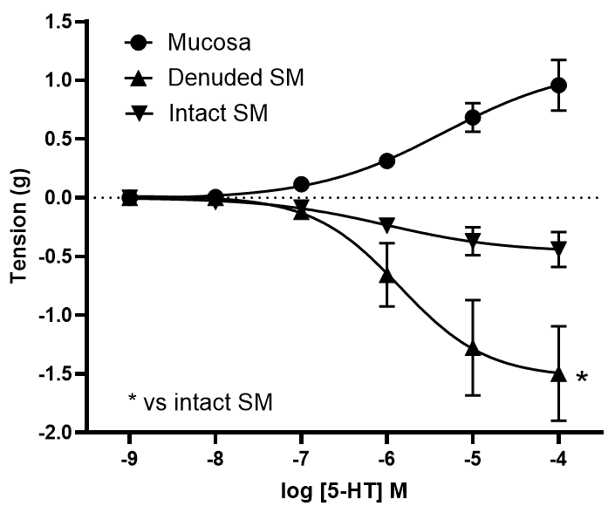
Introduction. Clinical pharmacological treatments available for stress urinary incontinence are limited (Harland et al., 2023).
Aims. The present study aimed to investigate the effects of 5-HT in the porcine urethra, to explore potential new treatment targets.
Methods. Using an organ bath setup, contractile responses of isolated porcine proximal urethral strips (denuded smooth muscle, mucosa-intact smooth muscle, and mucosa) to increasing concentrations (10 nmol/L – 100 μmol/L) of 5-HT were examined. In another set of experiments, concentration responses to 5-HT were repeated in the absence and presence of ketanserin (30 nmol/L) in paired tissue strips. Paired Student’s t-tests were performed to identify statistically significant differences where a p-value of < 0.05 was considered statistically significant.
Results. When subjected to 5-HT, the urethral mucosal strips generated a concentration-dependent increase in tone, while the smooth muscle strips concentration-dependently relaxed. Urethral smooth muscle strips with intact mucosa relaxed significantly lesser than strips denuded of mucosa. At higher concentrations of 5-HT (10 μmol/L and above), the spontaneous contraction rate exhibited by the mucosa was significantly enhanced (p=0.0013). Ketanserin (30 nmol/L) significantly attenuated the 5-HT-induced tonic contractions in the mucosal strips (p=0.0026), but did not affect the 5-HT-induced relaxatory responses in urethral smooth muscle strips or the 5-HT-induced increase in spontaneous contraction rate in mucosal strips (p>0.05).
Discussion. The present findings suggest that 5-HT-induced tonic contractile responses in the urethral mucosa is mediated by the 5-HT_{2A} receptor subtype.

Harland N et al (2023) Biomedicines 11:2486

