Abstract

Lipid-lowering & anti-inflammatory, of statin–ezetimibe and bempedoic acid–ezetimibe in dyslipidemics

Ved Prakash¹, Rajpal Prajapati², Aditya kalpande¹, Nidhi Goel³, Pharmacology dept, IMS-BHU¹, Varanasi, Uttar Pradesh, India; Cardiology dept, IMS-BHU², Varanasi, Uttar Pradesh, India; Pharmacology dept, IMS-BHU¹, Varanasi, Uttar Pradesh, India; Pathology dept, BKASMC³, Chandauli, Uttar Pradesh, India.

Introduction: Dyslipidemia is a substantial risk factor for cardiovascular disease, largely in the Indian population with wider disemination of atherogenic dyslipidemia and metabolic syndrome. Statins remain the frontline therapy, while Ezetimibe and newer non-statin agents such as Bempedoic acid offer additional lipid-lowering effects, particularly in patients intolerant or inadequately controlled on statins. Limited data exist comparing statins, bempedoic acid, and their combinations with ezetimibe in the North Indian population.
Aim: To evaluate the safety and efficacy of Statin + Ezetimibe versus Bempedoic acid + Ezetimibe in dyslipidemic patients at a tertiary care center in North India, with focus on lipid profile parameters, hs-CRP, and HbA1c over 12 weeks.
Methods:
A prospective, randomized, parallel-group study was conducted on 120 patients with dyslipidemia, divided into two groups (n=60 each): Group A: Statin(10mg) + Ezetimibe(10mg) vs Group B: Bempedoic acid(180mg) + Ezetimibe(10mg). Parameters measured at baseline, 4, 8, and 12 weeks included lipid profile (TC, LDL-C, HDL-C, TG), hs-CRP, and hba1c. Safety was assessed by adverse event monitoring and liver/renal function tests.
Results: Both the groups groups demonstrated significant reductions in LDL-C and total cholesterol by week 12 (p<0.001). Statin + Ezetimibe achieved the greatest LDL-C reduction (~50%), while Bempedoic acid + Ezetimibe showed moderate but clinically meaningful reduction (~30–35%). Hs-CRP decreased significantly in both statin and Bempedoic acid groups, suggesting anti-inflammatory efficacy. Hba1c remained stable across both groups, with no significant glycemic worsening. Safety profile was favorable in all groups, with fewer muscle-related adverse effects reported in the Bempedoic acid arm compared to statins.

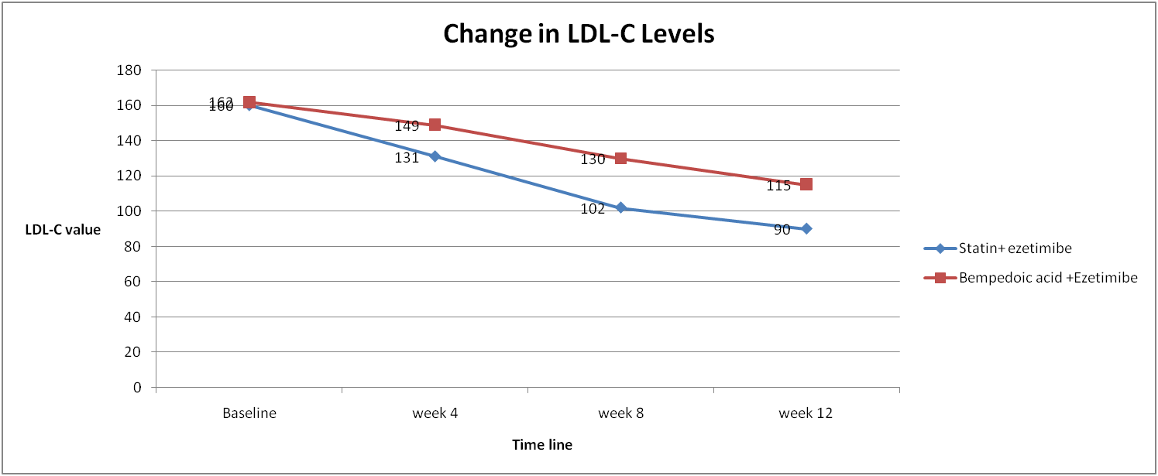

Conclusions:
In the North Indian dyslipidemic population, both Statin + Ezetimibe and Bempedoic acid + Ezetimibe were effective and well-tolerated. Statins achieved superior LDL-C lowering, while Bempedoic acid provided an alternative for patients with statin intolerance, with additional hs-CRP reduction and metabolic neutrality. These findings support the role of Bempedoic acid as an emerging non-statin therapy in Indian clinical practice.

References
- Ballantyne CM, Banach M, Mancini GBJ, et al.(2018). Efficacy and safety of bempedoic acid added to ezetimibe in statin-intolerant patients with hypercholesterolemia: A randomized, placebo-controlled study. Atherosclerosis. 277:195-203.
- Goldberg AC, Leiter LA, Stroes ESG, et al.(2019). Effect of Bempedoic Acid vs Placebo Added to Maximally Tolerated Statins on Low-Density Lipoprotein Cholesterol in Patients at High Risk for Cardiovascular Disease: The CLEAR Wisdom Randomized Clinical Trial. JAMA. 322(18):1780-1788.
- KK Ray, RS Wright, D Kallend, et al.(2020). Two phase 3 trials of inclisiran in patients with elevated LDL cholesterol. N Engl J Med, 382: 1507-1519
- Mach F, Baigent C, Catapano AL, et al.(2020). 2019 ESC/EAS Guidelines for the management of dyslipidaemias: lipid modification to reduce cardiovascular risk. Eur Heart J. 41(1):111-188.
- Sharma S, Gaur K, Gupta R.(2024). Trends in epidemiology of dyslipidemias in India. Indian Heart J.76 Suppl 1(Suppl 1):S20-S28.

