Predicting ligand affinity at the human A₃ adenosine receptor from protein sequence
Thomas J Lonsdale¹, Huan Y Koh², Daniel P Poole¹, Nicholas A Veldhuis¹, Lauren T May¹.
Monash Institute of Pharmacological Sciences, Monash University¹, Parkville, VIC, Australia; Faculty of Information Technology, Monash University², Clayton, VIC, Australia.
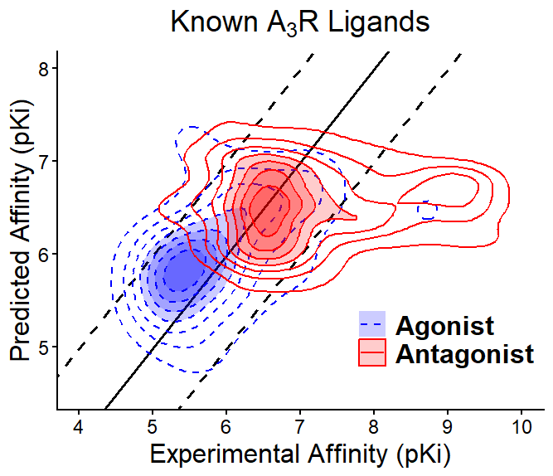
Introduction. PSICHIC, a physicochemical graph neural network, predicts protein-ligand interactions from sequence data with accuracy that outperforms or is comparable to other structure-based and sequence-based models (Koh et al., 2024). The current study evaluated PSICHIC predictions of agonist and antagonist binding affinities at the A₃ adenosine receptor (A₃R), a potential non-opioid target for the treatment of nociceptive and neuropathic pain.
Aims. Investigate how PSICHIC-predicted A₃R binding data compares to experimentally derived values.
Methods. BindingDB was used to obtain binding affinity data for the human A₃R. PSICHIC was used to predict binding affinity. Analysis was conducted in RStudio, including calculations of mean absolute error (MAE).
Results. In general, PSICHIC predicted binding affinity values for the A₃R with a similar level of accuracy as previously described (MAE_{ALL} = 1.04). A stronger correlation was observed for experimental values derived from radiolabelled antagonist data, as compared to radiolabelled agonist data (MAE_{ANT} = 1.00, MAE_{AGO} = 1.13). Interestingly, PSICHIC-predicted binding affinities were substantially lower than reported experimental values for a subset of A₃R antagonists, predominantly belonging to a class of urea-containing compounds (MAE_{UREA} = 2.20).
Discussion. Urea-containing antagonists were particularly susceptible to discrepancies between experimental and predicted binding affinity values, suggesting these discrepancies may reflect a specific physicochemical characteristic of these ligands. Notably, many A₃R ligands were assigned functionality based on their structures, suggesting that further pharmacological characterisation of these antagonists is required to ensure accurate classification. Our results highlight the utility of PSICHIC in drug discovery and the potential for this approach to provide pharmacological insights.
Koh HY et al. (2024) Nat Mach Intel 6:673-687.

