**Neutralised electrohydrodynamic for biomedical and micromechatronic application**

*Van Thanh DauA, Tuan-Khoa NguyenB, Toan DinhB and Dzung Viet DaoA,B*

A*School of Engineering and Built Environment, Griffith University, Gold Coast, 4215, Australia*

B*Queensland micro and nano technology centre, Griffith University, Brisbane, 4111, Australia*

Introduction.

Electrohydrodynamic atomization (EHDA) is a promising and powerful technique to generate either high-velocity airflow, nanometer-scale droplets, particles or fibers [1]. A typical EHDA system consists of an atomising electrode and a reference electrode placed downstream to form an electric field. However, due to the electrostatic force, most of the generated products land on the reference electrode where they are collected and re-delivered by other dispensing technologies. In this work, we aim to develop novel EHDA system that generates and delivers electroneutral products without the restriction of collector electrode, thereby empower the practical development of EHDA devices for aerosol drug delivery and micromechatronic system.

Methods.

We resolve the above technical barrier by developing a bipolar corona-assisted EHDA system with a functional counter electrode generating oppositely charged ionic flow. By further matching the initial droplet’s momentum with the electric field, the oppositely charged droplets are forced to recombine in the vicinity of the atomising electrode. Thus, they are neutralised and do not attract to the counter electrode, to the contrary of classical EHDA systems.

Results and Discussion.

The neutralised EHDA airflow can be generated and stably circulated in a confined space to develop a cost-effective fluidic angular rate sensor. This novel EHDA based sensor can detect high angular rate, with long-term drift is only ∼ 1%. When the EHDA discharges at 2.5 kV, a scale factor up to 7.3 µV(º/s)-1 is achieved.

Alternatively, we can generate and deliver neutralised nanodroplets via the stable cone jet. In the optimal voltage range ∼4kV, the measured charge of the droplet stream was reduced by 99.5% in comparison with classic EHDA systems, and the stream of nanodroplet visually expands more than 150 mm downstream. This stream, recorded by an aerosol meter, shows high particle concentration sizing 100 – 500 nm, proves that charge reduced nanodroplets are efficiently generated and delivered.

Finally, we demonstrate that the developed EHDA system is also capable of electrospinning polymeric nanofiber by manufacturing a polyacrylonitrile-carbon nanotube-polyacrylonitrile (PAN-CNT-PAN) flexible platform for multifunctional electronic devices. The platform can be utilised as flexible sensing-and-heating with high porosity, a fast response time of 1.5s and high sensitivity of 340mV(m s-1)-1.

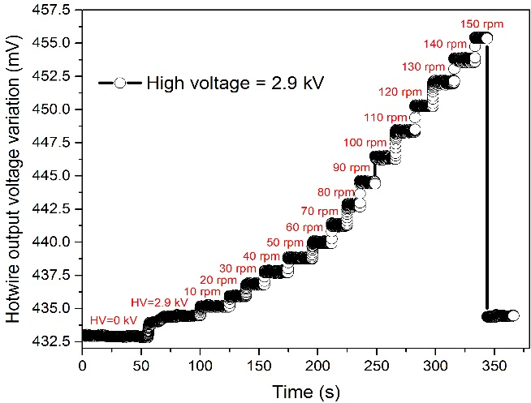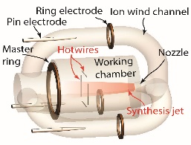

a)

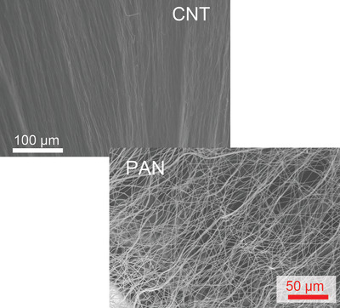

b)

Figure:(a)Angular rate sensing by EHDA sensor; inset shows the sensor configuration and (b) an image of CNT and PAN membrane fabricated by developed EHDA system.

**References**

1. Yoo, J.W., et al., *Bio-inspired, bioengineered and biomimetic drug delivery carriers.* Nat Rev Drug Discov, 2011. **10**(7): p. 521-35.