**Improving interfacial solar steam generation by energy management**

*Haolan Xu*

Future Industries Institute, University of South Australia, Mawson Lakes Campus, Adelaide, Australia.

Access to clean drinking water is essential for human health. However, worldwide about 10% of world population routinely suffer from clean water shortage due to drought, water pollution and also simply due to lack of cost-effective water purification system.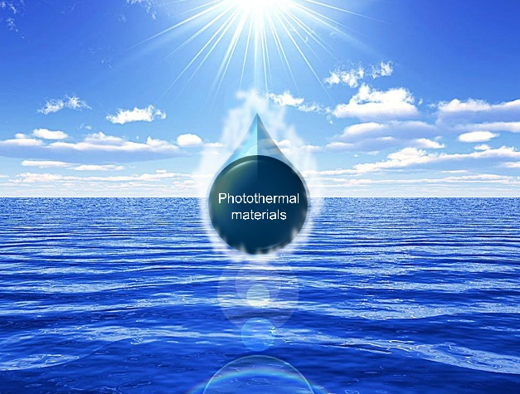 Solar-steam generation offers a cost-effective strategy for clean water production driven by sustainable solar energy.1,2 It involves sunlight absorption, conversion, localization and interfacial water evaporation. In recent years, great effort has been devoted to improving energy efficiency of the solar-steam generation to facilitate its real-world applications. One of the method is enhancing light absorption and light-to-heat conversion over the photothermal materials. However, many reported photothermal materials have reached 97% of light absorption,3-4 thus there is no big room for further improvement. Energy management during solar evaporation is an alternative and promising way to improve the efficiency of solar-steam generation. The ideal solar evaporation system should has minimized energy loss, while maximized energy gain from the environment.5 Herein, novel photothermal evaporators which enable simultaneously decrease energy loss, increase energy gain from the environment and energy recycling for solar steam generation with an energy efficiency beyond the theoretical limit are introduced.

**References**

1. Tao, P.; Ni, G.; Song, C.; Shang, W.; Wu, J.; Zhu, J.; Chen, G. & Deng T. (2019). Solar-driven interfacial evaporation. Nat. Energy, 3, 1031-1041.
2. Wu, X.; Chen, G.; Owens, G.; Chu, D. & Xu, H. (2018). Photothermal materials: a key platform enabling highly efficient water evaporation driven by solar energy. Mater. Today Energy, 12, 277-296.
3. Wu, X.; Robson, M.; Phelps, J.; Tan, J.; Shao, B.; Owens, G. & Xu, H. (2019). A flexible photothermal cotton-CuS nanocage-agarose aerogel towards portable solar steam generation. Nano Energy, 56, 708-715.
4. Wu, X.; Wu, L.; Tan, J.; Chen, G.; Owens, G. & Xu, H. (2018). Evaporation above a bulk water surface using an oil lamp inspired highly efficient solar-steam generation strategy. J. Mater. Chem. A, 6, 12267-12274.
5. Li, X.; Li, J.; Lu, J.; Xu, N. & Zhu, J. (2018). Enhancement of interfacial solar vapor generation by environmental energy. Joule, 2, 1331-1338.