Boron-Based Topical Strategy for Enhancing Flap Survival: Mechanistic Insights Through Proteomic Analysis
Cafer Yildirim¹, Merve Gulsen Bal Albayrak², Sevinc Yanar³, Nihal Kayir⁴, Ayse Hande Yozgat⁵, Sevim Aydin⁵ and Fikrettin Sahin⁶. Department of Basic Medical Sciences, Ankara University¹, Ankara, Turkiye; Department of Molecular Gastroenterology and Hepatology, Kocaeli University², Kocaeli, Turkiye; Department of Medical Biology, Ankara Yildirim Beyazit University³, Ankara, Turkiye; Department of Medical Pharmacology, Medipol University⁴, Istanbul, Turkiye; Department of Histology and Embryology, Ankara University⁵, Ankara, Turkiye; Department of Genetics and Bioengineering, Yeditepe⁶ University, Istanbul, Turkiye
Introduction: Flap survival is often compromised by ischemia–reperfusion injury, oxidative stress, and inadequate angiogenesis, leading to distal necrosis in 20–80% of experimental models and 10–25% of clinical cases. Although various pro-angiogenic and antioxidant therapies have been explored, clinical translation remains limited. Boron has shown promise as a modulator of inflammatory and angiogenic pathways, enhancing fibroblast activity and VEGF expression in wound models; however, boron-containing hydrogels have not yet been evaluated in flap ischemia models, highlighting an important translational gap (1,2).
Aims. This study aimed to evaluate the therapeutic efficacy of a sodium pentaborate pentahydrate (SPP)-containing hydrogel in a rat flap model by assessing its effects on angiogenesis, inflammation, extracellular matrix organization, and molecular signaling through histological and proteomic analyses.
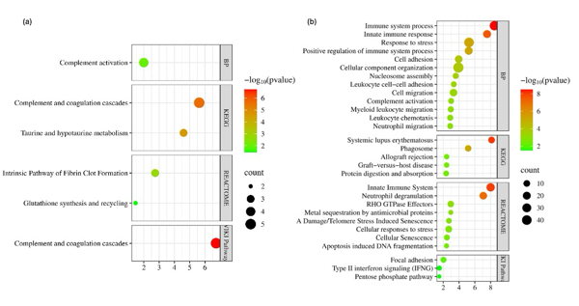
Methods: The rats were randomly assigned to two groups (n = 8 per group): control and DBP-treated. Rats were given anesthesia combination of 5 mg/kg xylazine hydrochloride and 50 mg/kg ketamine hydrochloride. A dorsal flap model was established in male Wistar rats, which were treated topically with an SPP-containing formulation twice daily for seven days. Histological changes were evaluated using H&E and M&T staining, and proteomic alterations were analyzed using label-free nano LC-MS/MS followed by bioinformatics analysis.
Results: Treatment significantly improved flap survival (p< 0.0001), enhanced granulation tissue formation, promoted organized collagen deposition, and reduced inflammation. Proteomic analysis identified 179 differentially expressed proteins (14 upregulated, 165 downregulated); enriched pathways indicated activation of complement, antioxidant, and extracellular matrix remodeling processes, alongside suppression of immune overactivation and cellular stress, suggesting a shift toward controlled inflammation and tissue homeostasis. To our knowledge, this is the first study demonstrating that an SPP-containing hydrogel enhances flap healing by promoting vascularization, modulating immune responses, and supporting matrix remodeling, highlighting its potential in reconstructive surgery.
Discussion. The present findings are consistent with previous experimental and clinical studies reporting that boron-containing hydrogels enhance angiogenesis, fibroblast activity, and collagen synthesis, supporting improved tissue regeneration in various wound models. Moreover, our proteomic data suggest that DBP promotes flap healing by suppressing excessive inflammatory and IFN-γ–related responses while reinforcing antioxidant and coagulation pathways, aligning with earlier reports highlighting boron’s immunomodulatory and oxidative stress–regulating effects.
References
- Liu, H.; Zhang, M.; Dong, X.; Liu, Y.; Hao, Y.; Wang, Y. Necrostatin-1 Protects against Ischemia/Reperfusion Injury by Inhibiting Receptor-Interacting Protein 1 in a Rat Flap Model. J. Plast. Reconstr. Aesthetic Surg. 2019, 72, 194–202.
- Zhou, T.; Wang, X.; Wang, K.; Lin, Y.; Meng, Z.; Lan, Q.; Jiang, Z.; Chen, J.; Lin, Y.; Liu, X.; et al. Activation of Aldehyde Dehydrogenase-2 Improves Ischemic Random Skin Flap Survival in Rats. Front. Immunol. 2023, 14, 1127610.

