PHOENIX: Early Progress from a Pre-Emptive Pharmacogenomics trial
Stefanie Lip¹, Iain Frater¹, Eleanor Carter¹, Nekmee Gunasekera ¹, Roisin Cannon ¹, Usmaan Razzaq ¹, Linsay McCallum ², Sean MacBride-Stewart², Alex McConachie¹, PHOENIX Trial Team, Sandosh Padmanabhan¹
¹University of Glasgow, Glasgow, Scotland, UK; ²NHS GG&C, Glasgow, Scotland, UK
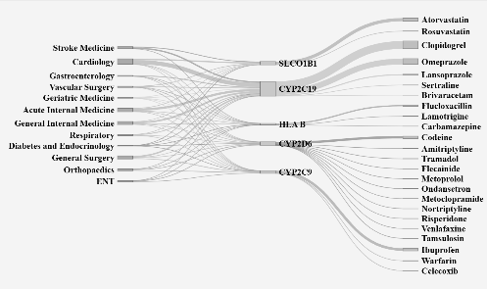
Introduction. Pharmacogenomics (PGx) can improve prescribing safety and efficacy by reducing adverse drug reactions and treatment failures through genotype-guided care. However, further evidence is needed for UK NHS implementation.
Aims. To obtain preliminary clinical and cost-effectiveness of pre-emptive PGx-guided prescribing in patients receiving secondary care within Glasgow, Scotland.
Methods. PHOENIX (NCT06907784) is an ongoing two-arm, parallel RCT (Apr 9, 2025–Sept 30, 2026). Adults newly prescribed one of 60+ PGx-implicated index drugs, are randomised 1:1 to immediate PGx-guided prescribing or standard care -delayed PGx testing at three months. DNA is shipped thrice weekly from Glasgow, UK to GenebyGene (Houston, USA), for 16-gene analysis with reports generated by MyDNA (Australia) and returned securely to the trial team. The primary outcome is ADRs or treatment failure within 3 months assessed by routine data linkage and participant-reports.
Results. By 15 Jan 2026, 1,231 participants were randomised, averaging ~127/month; 45% female; mean age 55±18 years; spanning 26 specialties. Index prescribing shows clopidogrel (~27%), omeprazole (~23%), atorvastatin (~12%), ibuprofen (~11%), and codeine (~9%) accounting for ~80% of starts. Early activity clusters around a subset of genes: CYP2C19 (~54%), CYP2D6 (~15%), CYP2C9 (~12%), SLCO1B1 (~12%), and HLA-B (~7%).
Discussion. Early PHOENIX data suggest that acute-care pharmacogenomics operates as a system-level intervention, with a small core gene set and widely used medicines spanning many specialties.

