Regulation of enzymatic lipid peroxidation in osteoblasts protects against postmenopausal osteoporosis
Qiong-Yi Zhang, Rong-Rong He, Yi-Fang Li. College of Pharmacy, Jinan University, Guangzhou, China

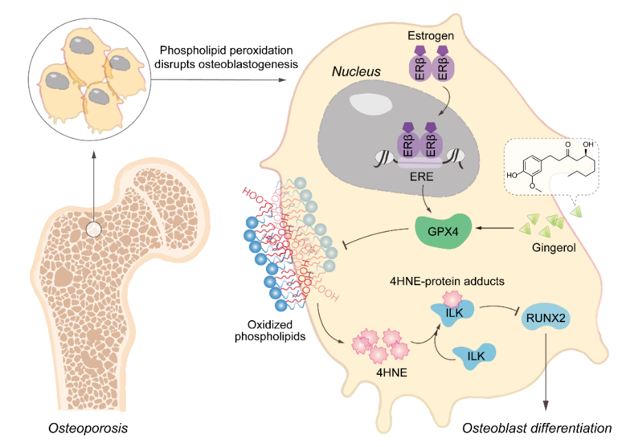
Introduction. Oxidative stress plays a critical role in postmenopausal osteoporosis, yet its impact on osteoblasts remains underexplored, limiting therapeutic advances.
Aims. To clarify the role and mechanism of osteoblast phospholipid peroxidation in postmenopausal osteoporosis and explore potential therapeutic strategies.
Methods. Clinical bone specimens, ovariectomized and aged mouse models, osteoblast-specific GPX4 knockout, oxidized phospholipidomics, and molecular mechanistic assays were employed to investigate phospholipid peroxidation in osteoporosis.
Results. Phospholipid peroxidation was elevated in osteoporotic bone, particularly in osteoblasts. Estrogen upregulated GPX4 via ERβ, while estrogen deficiency reduced GPX4 and increased oxPLs. GPX4 loss or impairment suppressed osteoblastogenesis and bone formation. Mechanistically, 4‑HNE promoted ILK degradation, suppressed RUNX2 signaling, and inhibited osteogenic differentiation. 6‑Gingerol and 8‑Gingerol acted as natural allosteric GPX4 activators, restoring osteoblast function and mitigating bone loss.
Discussion. This study identifies osteoblast phospholipid peroxidation as a critical driver of postmenopausal osteoporosis and highlights GPX4-targeted regulation as a promising therapeutic strategy for osteoporosis and related skeletal disorders.

Zhang Q-Y et al (2025) Nature Communications 16:758.

