Advancing Drug–Drug Interaction research: A multidisciplinary framework linking mechanistic evidence, AI‑driven modelling, and clinical application
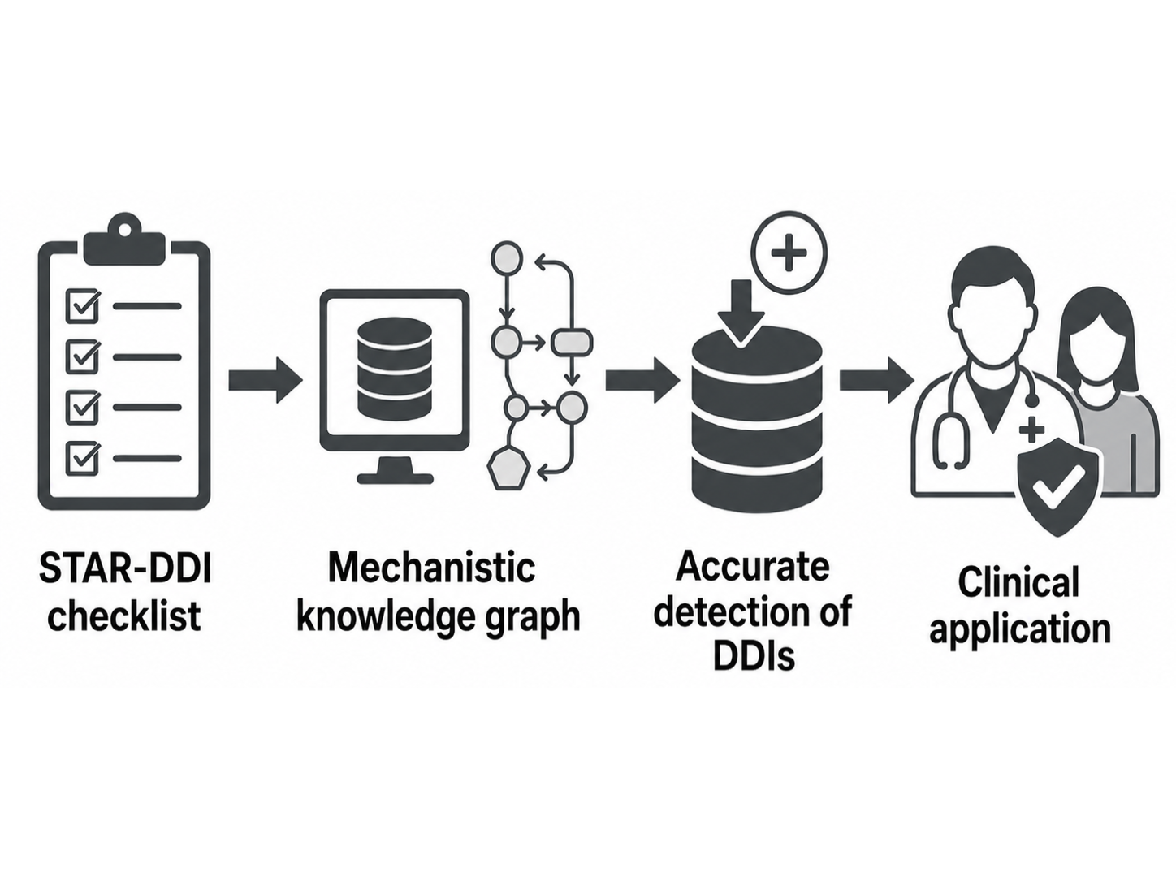
Brayden Gibson1 , Catia Marzolini2,3, Saye Khoo3, Lachlan Dalli4, Jack Janetzki5, Pilar Cataldo Miranda1, Danijela Gasevic1, Harvey Jia Wei Koh1, Stella Talic1. School of Public Health and Preventive Medicine, Monash University, Melbourne, VIC, Australia1; University Hospital of Lausanne, Lausanne, Switzerland2; University of Liverpool, Liverpool, UK3; Monash University, Melbourne, VIC, Australia4; University of South Australia, Adelaide, SA, Australia5.

Introduction. Drug-drug Interactions (DDIs) are a preventable form of medication related harm, but concerns have arisen from the reliability and validity of these tools, with inconsistencies in evidence requirements, and severity classifications limit comparability. We introduce STandArdised consensus-based Reporting checklist foR Drug–Drug Interaction checkers and databases (STAR-DDI), to address gap.
Aims. To present the findings from systematic review on DDI checkers and introduce a new reporting checklist -STAR-DDI. To describe the current state of drug interaction research, identify gaps in evidence translation and classification, and propose future directions for improving clinically meaningful drug interaction guidance.
Methods. A systematic review identified studies evaluating DDI checkers, and databases and related digital tools in chronic disease settings. Review findings informed candidate STAR-DDI checklist items, which were refined through an Delphi study involving clinicians, researchers, regulators, guideline developers and drug interaction specialists.
Results. The review identified poor to moderate agreement between DDI tools, inconsistent severity classification, variable reference standards and limited clinical validation. The Delphi study supported transparent reporting of evidence sources, curation processes, database features and conflicts of interest, but highlighted persistent uncertainty in defining severity and clinical relevance, particularly for mild and moderate interactions.
Discussion. These findings suggest that drug interaction research requires shared foundations before more advanced digital tools can be reliably implemented. STAR-DDI provides a starting framework for improving consistency across research, databases and clinical practice. Future work should align biomedical science, real world evidence research and computer science methods perspectives with future iterations as the field evolves to an advanced digital era.

