**Development of GalNAc-modified cyclodextrin for the treatment of Metabolic dysfunction-associated fatty liver disease**

**Rin Onaga**, Yuto Higa, Toru Taharabaru, Taishi Higashi, Keiichi Motoyama

Graduate School of Pharmaceutical Sciences, Kumamoto University, Kumamoto, Japan

**Background and aims.** Metabolic dysfunction-associated fatty liver disease (MASLD) is a chronic liver disorder characterized by lipid accumulation in the liver, affecting approximately 30% of the global adult population. MASLD is classified into simple steatosis and metabolic dysfunction-associated steatohepatitis (MASH) leading to fibrosis, cirrhosis, and hepatocellular carcinoma. Excessive accumulation of free cholesterol in the liver is reported to be involved in the pathogenesis of MASH.1 Recently, 2-hydroxypropyl-b-cyclodextrin (HP-b-CyD) has shown the therapeutic potential in the lipid storage disorders such as Niemann-Pick disease type C and Alzheimer’s disease, due to its lowering effects on cholesterol accumulation. Thus, HP-b-CyD may have a potential as the therapeutic agent for MASH. However, HP-b-CyD has a low blood retention and low hepatic accumulation. In this study, we aim to enhance the therapeutic potential of HP-b-CyD by introducing liver-targeting ability and improving intracellular delivery.

**Methods.** We developed *N*-acetylgalactosamine-modified HP-b-CyD (GalNAc-HP-b-CyD) (Figure 1), which is a novel HP-b-CyD derivative. GalNAc is a ligand for the asialoglycoprotein receptor (ASGPR), highly expressing on hepatocytes. We evaluated the cytotoxicity and the intracellular uptake of GalNAc-HP-b-CyD in hepatocytes. In addition, we evaluated the lowering effect of GalNAc-HP-b-CyD on free cholesterol accumulation by filipin staining in intracellular cholesterol transport inhibitor (U18666A)-treated hepatocytes.

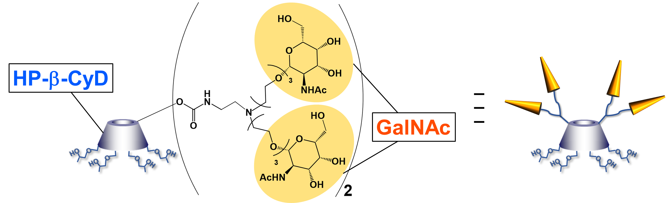

**Figure 1.** Schematic Structure of GalNAc-HP-b-CyD

**Results and Discussion.** GalNAc-HP-b-CyD showed negligible cytotoxicity in hepatocytes under the experimental conditions. Moreover, GalNAc-HP-b-CyD was significantly internalized into hepatocytes rather than HP-b-CyD. The intracellular uptake of GalNAc-HP-b-CyD was decreased in the presence of asialofetuin, a competitive inhibitor of ASGPR, suggesting that GalNAc-HP-b-CyD is internalized via ASGPR-mediated endocytosis. Furthermore, GalNAc-HP-b-CyD reduced free cholesterol accumulation in cholesterol-accumulated hepatocytes.

**Conclusion.** These results suggest that GalNAc-HP-b-CyD has the potential as a novel therapeutic agent for MASH.

**Acknowledgements:** This work was supported by JST SPRING, Grant Number JPMJSP2127.

**References:**

(1) Horn, C.L. et al (2022) Hepatol. Commun., 6, 12-35