**Development of Manganese and Gadolinium Co-doped Layered Double Hydroxide Nanoparticles as Sonosensitiser for MRI Guided Sonodynamic Therapy**

**Firasti AN Sumadi1**, Hang T. Ta2, Ruirui Qiao1, Run Zhang1*\**

1 Australian Institute for Bioengineering and Nanotechnology, The University of Queensland, Brisbane, Queensland, Australia

2 School of Environment and Science, Griffith University, Brisbane, Queensland, Australia

E-mail: *f.sumadi@uq.edu.au; r.zhang@uq.edu.au*

**Background and aims.** Sonodynamic therapy (SDT) is an emerging non-invasive therapeutic approach that utilises clinically accepted ultrasound to activate sonosensitiser and regulate reactive oxygen species (ROS) within the pathological microenvironment [1,2]. Combination of sonosensitisers with MRI contrast agents enables the therapeutics guided by imaging to enhance the treatment precision and effectiveness of SDT [3].

**Methods.** In this work, we developed dMn0.6Gd0.01-LDH@PEG-PA/DM (defect Manganese Gadolinium Layered Double Hydroxide) as a multifunctional nanosonosensitiser. The material was evaluated through a series of in vitro experiments using 4T1 breast cancer cells, as well as in vivo studies in tumour-bearing mouse models. In vitro studies were conducted using 4T1 breast cancer cells, to evaluate ROS generation, cellular uptake, cytotoxicity, and live/dead cell under ultrasound (2W/cm2, 50 kHz, 2 min) with and without the presence of H2O2 (50µM, pH 6.5) mimicking the tumour microenvirontment. For the in vivo experimentdMn0.6Gd0.01-LDH@PEG-PA/DM will be intravenously administered into 4T1 tumour-bearing BALB/C mice, and the biodistribution and tumour growth were evaluated over time with and without ultrasound irradiation.

**Results.** Upon mild ultrasound exposure, dMn0.6Gd0.01-LDH exhibits high generation rates of hydroxyl radical (•OH) and superoxide anion (O2•-) for cancer cells ablation. Additionally, dMn0.6Gd0.01-LDH has high T1 and T2 relaxivity, supporting its application as a dual-mode contrast agent for MRI imaging. Moreover, coating the particles’ surface with pH-responsive polymer (PEG/PA-DM) prolongs the circulation time and tumour accumulation for enhanced MRI-guided SDT [4].

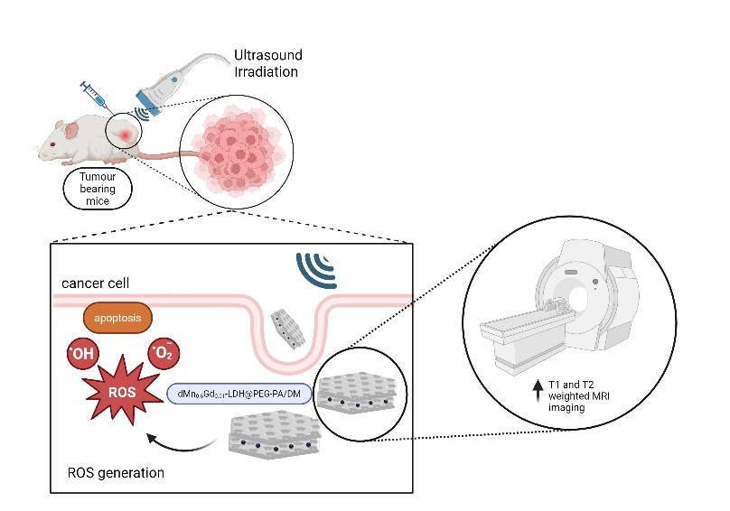

**Figure 1.** Schematic illustration of a multifunctional nanosensitiser dMn0.6Gd0.01-LDH@PEG-PA/DM for MRI contrast enhancement and ROS-mediated anticancer therapy.

**Conclusion.** The successful development of dMn0.6Gd0.01-LDH introduces a promising nanosensitiser for the MRI-guided SDT platform, offering synergistic advantages in the diagnosis and treatment of cancer.

**References:**

1. M. Wu, X. Niu, R. Zhang, Z. Xu, *Advanced Drug Delivery Reviews*, **2022**, *187*, 114360
2. M. Wu, J. Yong, H. Zhang, Z. Wang, Z. Xu, R Zhang, *Advanced Healthcare Materials*, **2023**, *12*, 2301497
3. J. Liu, L. Li, R. Zhang, Z. Xu, *Nanoscale Horizons*, **2023**, *8*, 279-290
4. J. Liu, Y. Wu, C. Fu, B. Li, L. Li, R. Zhang, T. Xu, Z. Xu, *Small*, **2020**, *16*, 2002115