**Treatment of experimental autoimmune encephalomyelitis with lipid nanoparticles loaded with siRNA targeting neogenin**

**Kosuke Shimizu1**

Nanotheranostics Laboratory, Division of Innovative Diagnostic and Therapeutic Research, Institute of Photonics Medicine, Hamamatsu University School of Medicine, Hamamatsu, Japan

**Background and aims.** Multiple sclerosis (MS) develops due to an abnormal T-cell immune response to autoantigens and control of T-cell activation is a mainstream approach for its treatment (1). In the present study, neogenin, a key molecule for T-cell activation, was used as a targeted molecular gene therapy for MS. Lipid nanoparticles (LNPs) loaded with siRNA-targeting neogenin (LNPsiNeo) were prepared, and their therapeutic effect on experimental autoimmune encephalomyelitis (EAE) induced by myelin oligodendrocyte glycoprotein (MOG), a model of MS was evaluated (Fig.1).

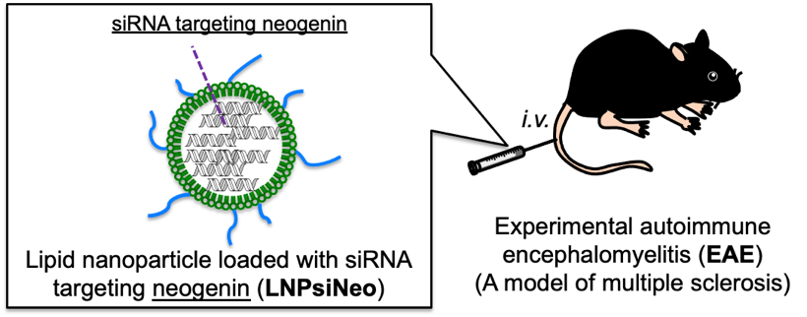

Fig. 1. Therapeutic strategy for the treatment of EAE.

**Methods.** To prepare LNPs loaded with siRNA, ethanol solution containing DLin-MC3-DMA, DSPC, Cholesterol, and DMG-PEG2000 was mixed with three times volume of 25 mM sodium acetate solution (pH 4.5) containing siRNA targeting GFP (siGFP) or neogenin (siNeo) (flow rate: 1.5 mL/min) to give a negative/positive (ratio of 6) in a microfluidic mixer using two syringe pumps. After dialysis with both 50 mM MES/citrate buffer (pH 6.7) and PBS (pH 7.4), LNPs loaded with siGFP (LNPsiGFP) or siNeo (LNPsiNeo) were obtained. To evaluate *in vitro* gene silencing effect, mouse T cell like-lymphoma EL-4 cells were incubated with LNPsiGFP or LNPsiNeo (1, 10, or 100 nM siRNA) and after 48 h of incubation, the cells were lysed and gene expression of neogenin was confirmed using a RT-qPCR assay. For in vivo experiments, a MS model of EAE mouse was prepared: MOG (200 μg) mixed with complete Freund’s adjuvant containing Mycobacterium butyricum (500 μg) was subcutaneously injected into the back of C57BL/6 mice; and then pertussis toxin solution (200 ng/day) was intravenously injected into the mice via a tail vein at days 0, 2, and 4. To evaluate the effects of LNPsiNeo on the splenocytes, EAE mice were intravenously injected with LNPsiGFP or LNPsiNeo via a tail vein at 10 μg/mouse on days 11 and 14 after MOG immunization and their splenocytes were assayed for in vivo gene silencing of neogenin and for T-cell population with a FACS. Furthermore, therapeutic effect of LNPsiNeo on EAE was evaluated to monitor the clinical EAE signs of the mice intravenously injected with LNPsiNeo were monitored.

**Results.** Dynamic light scattering (DLS) measurement and transmission electron microscopy (TEM) showed that LNPsiNeo was stably dispersed in aqueous solution, with mean particle size of 151 nm. Neogenin gene expression was strongly reduced by LNPsiNeo in mouse EL-4 cells and the mRNA level of neogenin was decreased in the splenocytes of LNPsiNeo-injected EAE mice compared with that in non-treated EAE mice and this effect was not observed in LNPsiGFP-treated mice. Additionally, FACS revealed that the number of CD4+ T cells in the splenocytes of EAE mice decreased after intravenous injection of LNPsiNeo. Furthermore, the progression of encephalomyelitis symptoms was significantly suppressed by LNPsiNeo, whereas the lipid nanoparticle with control siRNA failed to show any effect.

**Conclusion/Discussion.** The present study suggests that neogenin is a target molecule for EAE gene therapy and LNPsiNeo may be suitable for the MS treatment.

**References:**

(1) Shimizu, K. et al (2021) J Control Release 335: 389-397